Telusko: Core Java 03

021 Array in Java part - 03
transfer statements
=================
1. break
2. continue
3. return
Q>
class Test{
public static void main(String args[]){
int x=0;
switch(x){
case 0:System.out.println("hello");
break ;//It is used to avoid fallthrough in switch
case 1:System.out.println("hi");
}
}
}
Predict the Output:
A.Compile Time Error
B. Some problem occured by jvm during execution
C.hello
hi
D. hello
Answer: D
Q>
class Test{
1,1<10(true)
loop
public static void main(String args[]){
for(int i=0; i<10; i++) {// i = 0,0<10(true),i =
if(i==5)
break;//control will come out of the executing
System.out.print(i);//0,1,2,3,4
}
}
}
Predict the Output:
A.Compile Time Error
B. Some problem occured by jvm during execution
C.0 1 2 3 4
D. 0 1 2 3 4 6 7 8 9
Answer: C
Q>
class Test{
public static void main(String args[]){
int x=10;
l1 : {
}
System.out.println("begin");
if(x==10)
break l1;
System.out.println("end");
System.out.println("hello");}
}
Predict the Output:
A.Compile Time Error
B. Some problem occured by jvm during execution
C. begin
end
D. begin
end
hello
E. None of the above
Answer: E(begin and hello will be printed)
Q>
class Test{
public static void main(String args[]){
int x=10;
if(x==10)
break;
System.out.println("hello");
}
}
Predict the Output:
A.Compile Time Error
B. Some problem occured by jvm during execution
C. hello
D. None of the above
Answer: A (break can be used in switch,loop and labelled block,otherplace compile
time error)
Q>
class Test{
public static void main(String args[]){
int x=2;
for(int i = 0; i<10;i++) {
if(i%x==0)
continue;//it will skip the current iteration and proceeds with
next iteration
System.out.println(i);
}
}
}
Predict the Output:
A. Compile Time Error
B. Some problem occured by jvm during execution
C. 0 2 4 6 8
D. 1 3 5 7 9
E. None of the above
Answer: D
Q>
{
class Test
public static void main(String args[]){int x=10;
if(x==10)
continue;//continue can't be used here
System.out.println("hello");
}
}
Predict the Output:
A. Compile Time Error
B. Some problem occured by jvm during execution
C. hello
E. None of the above
Answer: A
Q>
class Test{
public static void main(String args[]){
int x=0;
switch(x){
case 0:System.out.println("hello");
continue;
case 1:System.out.println("hi");
}
}
}
Predict the Output:
A.Compile Time Error
B. Some problem occured by jvm during execution
C.hello
hi
D. hello
Answer: A(continue can be used only in loops and labelled block,otherplaces compile
time error)
Note:
l1:
for()
{
l2: for()
{
l3: for()
{
break/break l3; // goto stmt-1
break l2; //goto stmt2
break l1;// goto stmt3
}
}
}
stmt-1;
stmt-2;
stmt-3;
Q>
class Test{
public static void main(String args[]){l1:for(int i=0;i<3;i++) // i = 0 ,0<3(true) , i =1, 1<3(true), i
=2 , 2<3(true), i = 3 , 3<3(false)
for(int j=0;j<3;j++)// j =0,0<1(true), j =1,
1<3(true),j =2 ,2<3(true)
{
if(i==j)
stmt1;
System.out.println(i+""+j);//10 20 21
}
}
}
}
replace stmt1 with break and predict the output?
Answer:1 0 2 0 2 1
replace stmt1 with break l1 and predict the output?
Answer: no output
replace stmt1 with continue and predict the output?
Answer: 01, 02,10,12,20,21
replace stmt1 with continue l1 and predict the output?
Answer: 10 20 21
Q>
class Test{
public static void main(String args[]){
while(true){
System.out.println("hello");//line-n1
}
System.out.println("hi");//line-n2
}
}
Predict the output
A. Compile time error at line-n1
B. some problem occured during jvm execution.
C. Compile time error at line-n2
D. hello
hi
E. hello infinite times
F. None of the above
Answer: C
Q>
class Test{
public static void main(String args[]){
if(true){
System.out.println("hello");//line-n1
}
else{
}
System.out.println("hi");//line-n2
}
}
Predict the output
A. compile time error at line-n1B. some problem occured during jvm execution.
C.Compile time error at line-n2
D. hello
hi
E. hello
F. hi
G. None of the above
Answer: E
Concept of unreachable holds good only for loops(for,while,dowhile), compiler will
ignore unreachable for
if else and switch syntax.
Q>
class A
{
void add(byte a, byte b)
{
}
//stmt;
class Test
}
{
public static void main(String[] arg)
{
A obj=new A();
obj.add(10,20); //Line 1 => CE: Why it is throwing CE. The value 10 is
inbetween byte range(-128 to 127 )
int i1=10;
byte b1=10; // Line 2 => Here Compiler accepting the value 10.
byte b2=i1; //Line 3 => CE
}
}

022 Linear Search, Binary Search, Bubble sort , Arrays class in Java
Q>
class Test{
public static void main(String[] args){
int x= 0;
do{
++x;
System.out.print(x);//1 4 8
if(++x<5)
continue;
++x;
System.out.print(x);//6 10
}while(++x<10);
}
}
JVM
x = 0,1,2,3,4,5,6,7,8,9,10,11
Output: 146810
Q>
class Test{
public static void main(String[] args){
for(int i =0;i++<5;i++){
System.out.println("hello");//3 times printed
i=i++;
}
}
}
A. 4
B. 3
C. 5
D. 2
How many times hello will be printed?
Answer: B
JVM
i =0,0<5(true) , i =1,2
i = 2,2<5(true), i =3,4
i = 4,4<5(true), i =5,6
i = 6,6<5(false), i =7
Q>
public class Test {
public static void main(String[] args) {
int i = 5;
System.out.print(i+++"");//5
System.out.print(i+"");//6
System.out.print(++i+"");//7
System.out.print(++i+i+++"");//8 + 8 = 16
}
}
Predict the Output?
A. 56716
B. 66616
C. 57817
D. 67817JVM
i = 5,6,7,8,9
Answer : A
Q>
public class Test {
public static void main(String[] args) {
int[] a ={0,2,4,1,3};
for (int i=0;i<a.length ;i++ )
a[i] = a[(a[i]+3)/a.length];
System.out.println(a[1]);
}
}
Predict the Output?
A. CompileTime Error
B. Some problem occured by jvm during execution
C. 0
D. 1
E. 3
F. None of the above
Answer: F(a[1] =2)
Q>
public class Test {
public static void main(String[] args) {
int i =0,j=5;
for (;(i<3) && (j++<10); ){
System.out.print("" + i + "" +j);
i++;
}
System.out.print(i +"" +j);
}
}
Predict the Output?
A. CompileTime Error
B. Some problem occured by jvm during execution
C. 06172838
D. 06172839
E. None of the above
JVM
i = 0,j =6 , 0<3(true) && 5<10(true)
0 6
i =1, j= 7, 1<3(true) && 6<10(true)
1 7
i =2, j =8 , 2<3(true) && 7<10(true)
2 8
i = 3, j =8 3<3(false)
3 8
Answer: C
Q>
public class Test {
public static void main(String[] args) {for (int i=0;i<10 ;i+=2 ){// i = i + 2
System.out.print(i);
}
}
}
Predict the Output?
A. CompileTime Error
B. Some problem occured by jvm during execution
C. 02468
D. 13579
E. None of the above
Answer: C(print even numbers)
Q>
public class Test {
public static void main(String[] args) {
int x =5;
x*= 3*5 + 7*x-1 + ++x; // x *= 3*5 + 7*x -1 + ++x
= 3*5 + 7*5-1 + 6
= 15 + 35-1+6
x* = 55
x = x*5
= 55*5 = 275
System.out.println(x);
}
}
Predict the Output?
A. CompileTime Error
B. Some problem occured by jvm during execution
C. 330
D. 275
E. None of the Above
Answer: D
public class Test {
public static void main(String[] args) {
int a =3;
switch (a){
case 1: ++a;
case 2: a++;
case 3: a++;//4
default: ++a;//5
}
System.out.println(a);//5
}
}
Predict the Output?
A. CompileTime Error
B. Some problem occured by jvm during execution
C. 7
D. 5
E. 6
F. None of the Above
Answer: D
Q>public class Test {
public static void main(String[] args) {
int i;
for (i=0;i<6 ;i++ ){
if (++i>3)
continue;
}
System.out.println(++i);
}
}
Predict the Output?
A. CompileTime Error
B. Some problem occured by jvm during execution
C. 7
D. 8
E. 6
F. None of the Above
i=1, 0<6(true), 1>3(false)
i=3, 2<6(true), 3>3(false)
i=5, 4<6(true), 5>3(true)
i=6, 6<6(false)
i = 7
Answer: C

import java.util.Arrays;

public class AC {

public static void main(String[] args) {
// TODO Auto-generated method stub

int[] a= new int[4];

for(int elem:a)
{
System.out.print(elem);
}
System.out.println();
Arrays.fill(a,5);
for(int elem:a)
{
System.out.print(elem);
}
System.out.println();

int[] ar= {1,2,0,0,0,4,5};
Arrays.fill(ar, 2, 5, 10);
for(int elem:ar)
{
System.out.print(elem + " ");
}
System.out.println();

int[] arr= {20,30,50,10,25,60};

Arrays.sort(arr);
for(int elem:arr)
{
System.out.print(elem + " ");
}
System.out.println();

int res=Arrays.binarySearch(arr, 35);
System.out.println(res);

}

}

public class BBS {

public static void main(String[] args) {
// TODO Auto-generated method stub
int[] a= {7,5,2,3,1,4,6};

for(int i=0;i<a.length;i++)
{
for(int j=1;j<a.length-i;j++)
{
if(a[j]<a[j-1])
{
int tempVar=a[j];
a[j]=a[j-1];
a[j-1]=tempVar;
}
}
}

for(int el:a)
{
System.out.print(el+" ");
}
}

}

import java.util.Scanner;

public class BS {

public static void main(String[] args) {
// TODO Auto-generated method stub

int[] ar= {10,20,30,40,50,60,70,80,90};

Scanner scan=new Scanner(System.in);
System.out.println("Enter the key to be searched");
int key=scan.nextInt();
int low=0;
int high=ar.length-1;

while(low<=high)
{
int mid=(low + high)/2;
if(key==ar[mid])
{
System.out.println("Key "+key+ " Found at index "+ mid);
break;
}
else if(key <ar[mid])
{
high=mid-1;
}
else if(key >ar[mid])
{
low=mid+1;
}
}
if(low>high)
{
System.out.println("Key not found");
}

}

}

import java.util.Scanner;

public class LS {

public static void main(String[] args) {
int[] ar= {10,20,40,30,60,70,80,90};
boolean flag=false;
Scanner scan=new Scanner(System.in);
System.out.println("Enter the key to be searched");
int key=scan.nextInt();

for(int i=0;i<ar.length;i++)
{
if(key==ar[i])
{
System.out.println("Key "+key+" found at index " + i);
flag=true;
break;
}
}

if(flag==false)
{
System.out.println("Key not found");
}

}

}

023 Bubble sort, Guesser Game Project, String in Java part 01
java.lang.String
================
String it refers to an Object in java present in package called java.lang.String(C)
String refers to collection of characters.
eg:: String s= "sachin";
System.out.println(s);//sachin
String s =new String("sachin");
System.out.println(s);//sachin
In java String object is by default immutable,meaning once the object is created we
cannot change the value of the
object, if we try to change then those changes will be reflected on the new object
not on the existing object.
case 1::
String s= "sachin";
s.concat("tendulkar");//(new object got created with modification so
immutable)
System.out.println(s);
output::sachin
vs
StringBuilder sb=new StringBuilder("sachin");
sb.append("tendulkar");//(on the same object modification so mutable)
System.out.println(sb);
output:: sachintendulkar
case 2:: String s1 = new String("sachin");
String s2 = new String("sachin");
System.out.println(s1==s2); //false
System.out.println(s1.equals(s2));//true
=> String class .equals method will compare the content of the object if
same return true otherwise return false
vs
StringBuilder sb1 = new StringBuilder("sachin");
StringBuilder sb2 = new StringBuilder("sachin");
System.out.println(sb1==sb2); //false
System.out.println(sb1.equals(sb2));//false
=> StringBuilder class .equals method for reference comparison
if differnt object returns false,even if the contents are same.
case 3:: String s =new String("sachin");
In this case 2 objects will be created one in the heap and the other one
in
the String Constant Pool, the reference will always point to Heap.
vs
String s ="sachin";
In this case only one object will be created in the SCP and it will be
referedby our reference.

What will be the result of compiling and executing Test class?
public class Test {
public static void main(String[] args) {
int a = 7;// a = 7,8,9
boolean res = a++ == 7 && ++a == 9 || a++ == 9; // 7==7(true) && 9==9(true)
|| a++=9 = true
System.out.println("a = " + a);
System.out.println("res = " + res);
}
}
A. a=10
res=true
B. a=9
res=true
C. a=10
res=false
D. compilation error
Answer: B
Q>
class Fork {
public static void main(String[] args) {
if(args.length == 1 | args[1].equals("test"))
System.out.println("test case");
} else {
System.out.println("production " + args[0]);
}
}
}
And the command-line invocation:
java Fork live2
What is the result?
A. test case
B. production live2
C. test case live2
D. Compilation fails
E. An exception is thrown at runtime
JVM
args[0] = live2
args.length= 1
Answer: E(ArrayIndexOutOfBoundsException becoz args[1] is not available)
Q>
public class Test {
public static void main(String[] args) {
int aVar = 9;// aVar = 10
if(aVar++ < 10) // if(9<10)true
System.out.println(aVar +" Hello World!");
else
System.out.println(aVar + " Hello Universe!");
}
}
A. 10 Hello World!
B. 9 Hello Universe!
C. 10 Hello WorldD. Compilation fails.
Answer: A
Q>
public class Test {
public static void main(String[] args) {
int[] a = {1,2,3,4,5};
for (xxx)
{
System.out.print(a[e]);
}
}
}
Which option can replace xxx to enable the code to print 135?
A. int e = 0; e < = 4; e++
B. int e = 0; e < 5; e + = 2
C. int e = 1; e < = 5; e + = 1
D. int e = 1; e < 5; e+ =2
a[0] = 1
a[1]= 2
a[2] = 3
a[3] = 4
a[4] = 5
Answer: B(becoz it should print data present in even index only)
Q>
public class Test {
public static void main(String[] args) {
int num = 5;//num=5,4
do{
System.out.println(num-- + "");//System.out.println(5)
}while (num == 0);
4==0(false)
}
}
What is the result?
A. 5 4 3 2 1 0
B. 5 4 3 2 1
C. 4 2 1
D. 5
E. Nothing is printed
F. 4
G. CompileTimeError
Answer: D
Q>
public class Test {
public static void main(String[] args) {
int ii=0;
int jj=7;
for (ii=0;ii<jj-1;ii=ii+2 ){
System.out.print(ii);
}
}
}What is the result?
A. 2 4
B. 0 2 4 6
C. 0 2 4
D. Compilation fails
JVM
ii =0 ,0<6(true)
ii=2, 2<6(true)
ii=4,4<6(true)
ii=6, 6<6(false)
Answer: 0 2 4
Q>
public class Test {
public static void main(String[] args) {
//line-3
array[0] = 10;
array[1] = 20;
System.out.print(array[0]+":" array[1]);
}
}
Which code fragment, when inserted at line 3, enables the code to print 10:20?
A. int[] array n= new int[2];
B. int[] array;
array = new int[2];
C. int array = new int[2];
D. int array [2] ;
JVM
A. int[] array n= new int[2];//invalid identifer
B. int[] array;//array declaration
array = new int[2];//array initialization
C. int array = new int[2];//[] is missing
D. int array [2] ;//new is missing
Q>
public class Test {
public static void main(String[] args) {
boolean opt =true;
switch (opt){
case true:System.out.print("True");
break;
default :System.out.print("***");
}
System.out.print("Done");
}
}
Predict the Output?
A. CompileTime Error.
B. Some problem occured by jvm during execution.
C. True
Done
D. True
***
DoneE. None of the above.
Note:
switch(arg)
|-> byte---> Byte
|-> short--->Short
|-> int ---> Integer
|-> char ---> Character
|->String
|-> enum
Answer: A
Q>
public class Test {
public static void main(String[] args) {
int intArr[] = {15,30,45,60,75};
intArr[2] =intArr[4];
intArr[4] = 90;
}
}
What are the values of each element in intArr after this code has executed?
A. 15, 60, 45, 90, 75
B. 15, 90, 45, 90, 75
C. 15, 30, 75, 60, 90
D. 15, 30, 90, 60, 90
E. 15, 4, 45, 60, 90
intArr[0] = 15
intArr[1] = 30
intArr[2] = 45,75
intArr[3] = 60
intArr[4] = 75,90
Output: 15,30,75,60,90
Answer: C
eg#3.
class Test{
public static void main(String[] args){
int x; //local variable
System.out.println("hello");
}
}
A. CE
B. some problem at runtime
C. hello
D. none of the above
Answer: C (becoz x is not used)
eg#4
class Test{
public static void main(String[] args){
int x;//local variable ---> no default initialization by jvm,
programmer should do
System.out.println(x);
}
}A. CE
B. some problem at runtime
C. hello
D. 0
E. none of the above
Answer: A (becoz x is not intialized)
eg#5.
class Test{
public static void main(String[] args) {
int x;
if(args.length>0){
x=10;
}
System.out.println(x);
}
}
Assume java Test 10 is passed throug command line
A. CE
B. some problem at runtime
C. hello
D. 10
E. none of the above
Answer: A(x = 10 is initialized inside block ,no gaurantee that block would be
executed by compiler)
eg#6
class Test {
public static void main(String[] args) {
int x;
if(args.length>0){
x=10;
}else{
x=20;
}
System.out.println(x);
}
}
A. CE
B. some problem at runtime
C. hello
D. 10
E. 20
F. None of the above
Assume java Test sachin is passed throug command line
java Test sachin
args[0] ="sachin"
args.length = 1
x =10
java Test
args.length = 0
x =20
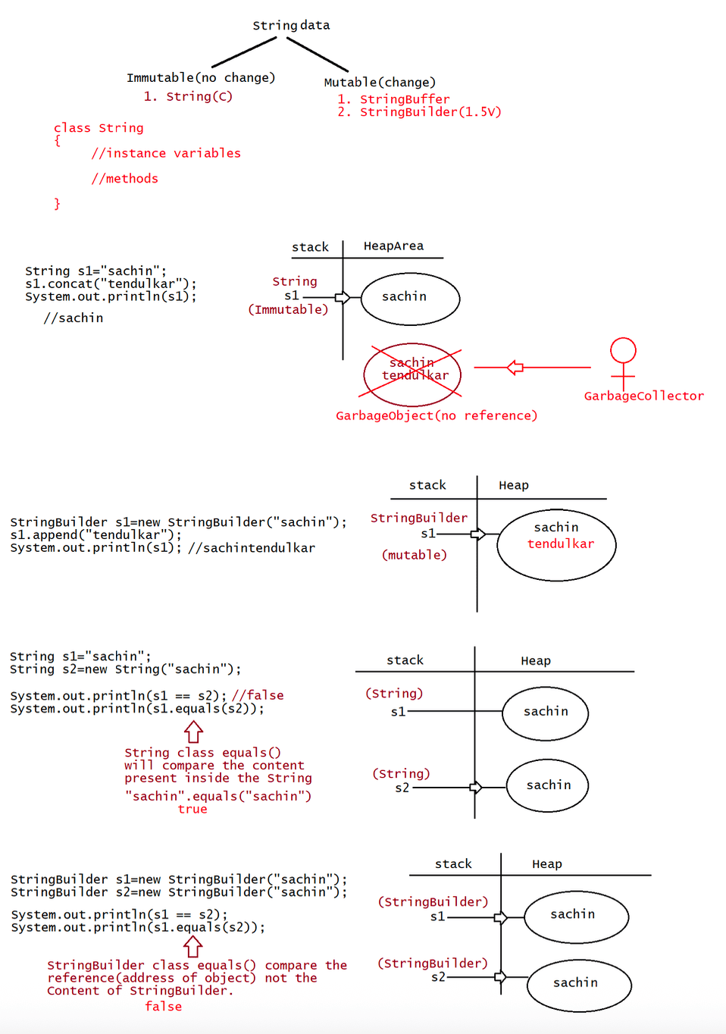
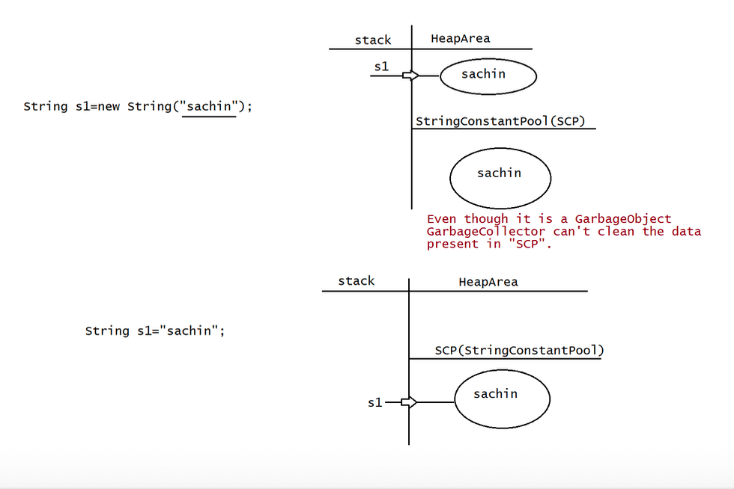

024 DOUBT
Today it is QA discussion from 2.05PM IST
Enterpise Java batch(weekends only)
FullStackJobGaurateed batch(daily 7.30PM IST to 10.30PMIST)
contact details
haider : syedhaider@ineuron.ai
nitin : nitin@ineuron.ai
Q>
sir how to take input from the user in the same line? If we write like this
Scanner scan= new Scanner (System.in);
System.out.println("Enter the value of a:");
int a=scan.nextInt();
System.out.println("Enter the value of b:");
int b= scan.nextInt();
then for b value it will go to next line
java FileName 10 20
Integer a = (Integer) arg[0]
Integer b = (Integer) arg[1];
Q> I pass the array to funcation that function smply only return what it will do i
got from one mcq
class A {
psvm(String[] args){
int arr[] ={1,2,3,4,5};
m1(arr)
for(int elem: arr)
System.out.print(arr);//1 ,2 ,3,50,5
}
public static void m1(int[] arr){
arr[3] = 50;
return;
}
}
Q>
for (int i=0;i<10 ;i+=2 ) sir increment/decrement
but here inisilize i+=2
in for loop after boolean it is necessary
for(stm1;stmt2;stm3){
//body of loop
}
stmt1=> any valid java statement but suggested in initalisation one
stmt2 => compulsorily boolean only
stmt3 => any valid java statement but suggested in increment/decrement
eg: i++,++i, i = i+1, i+=1,i+=2
Q> sir first statement we can write sop(" hii")
Answer :yes
Q>how to define 2D ARRAY confusion in brackets?
int[] a ={10,20,30};
int[][] a = {
{10,20,30},{40,50,60}
}
int[][][] a = {
{
{10,20,30},
{40,50,60}
},
{
{10,20,30},
{40,50,60}
}
};
Q>
how to declare array of class?
int[] arr =new int[5];//array of 5 integers
Student[] std=new Student[5];//array of 5 Students
Q>
what does in.ineuron.folder1.*(implicit import); mean? what I want to ask is, is it
going to
add or load all the classes at folder1's level or it adds all the classes
let's say in.ineuron.folder1.abc;(explicit import)
in.ineuron.folder1.xyz;
Q> Stack extends Vector, we have addElement(Object e) from Vector class,
also we have push(Object e) so what is the difference in these and which to
use when?
what makes them different?
Answer: Code would result in CompileTime Error.
Q>
int i=1,j=10;
do{
if(i++>--j)// 4>6
continue;
}while(i<5);
sop(i+""+j); // 5 6
sir what is the output?
JVM
i = 1,2,3,4,5
j = 9,8,7,6
Comparable and Comparator
========================

025 String with memory map in detail
Note:: Object creation in SCP is always optional,1st jvm will check is any object
already created with required content or not.
If it is already available then it will reuse the existing object
instead of creating the new Object.
If it is not available only then new object will be created, so we say
in SCP there is no chance of existing 2 objects with the same
content. In SCP duplicates are not permitted.
Garbage Collector cannot access SCP Area, Even though Object does not have
any reference still object is not eligible for GC.
All SCP objects will be destroyed only at the time of JVM ShutDown.
eg:: String s1=new String("dhoni");
String s2=new String("dhoni");
String s3="dhoni";
String s4="dhoni";
Output:: Two objects are creted in the heap with data as "dhoni" with reference
as S1,S2
One object is created in SCP with the reference as S3,S4.
case 4:: String s = new String("sachin");
s.concat("tendulkar");
s=s.concat("IND");
s="sachintendulkar";
Output:: Direct literals are always placed in SCP,Because of runtime operation if
object is required to create compulsorily that object
should be placed on the Heap,but not on SCP.
Q>
String s1= new String("sachin");
s1.concat("tendulkar");
s1+="IND";
String s2=s1.concat("MI");
System.out.println(s1);
System.out.println(s2);
Find out totally how many objects are created and how many are eligible for
garbage collection?
output: 8 and gc eligible is 2
Q>
String s1=new String("you cannot change me!")
String s2=new String("you cannot change me!");
System.out.println(s1==s2);
String s3="you cannot change me!";
System.out.println(s1==s3);
String s4="you cannot change me!";
System.out.println(s3==s4);
String s5="you cannot " + "change me!";
System.out.println(s3==s5);
String s6="you cannot ";
String s7=s6+"change me!";
System.out.println(s3==s7);final String s8="you cannot ";
String s9=s8+"change me!";
System.out.println(s3==s9);
System.out.println(s6==s8);
output
false
false
true
true
false
true
true
case7 :: Interning=> Using Heap object reference, if we want to get Corresponding
SCP Object, then we need to use intern() method.
eg1::
String s1 =new String("sachin");// One in heap(s1) and the other one in
SCP
String s2=s1.intern();//using s1 access object in SCP which has no
reference
System.out.println(s1==s2);//false
String s3="sachin";
System.out.println(s2==s3);//true
eg2::
Using heap object reference, if we want to get the corresponding SCP object and
if the Object does not exists,
then intern() will create a new object in SCP and it returns.
eg2::
String s1=new String("sachin");// One in heap(s1) and the other one in SCP
String s2=s1.concat("IND");// One in SCP(IND) and the other one in
heap(s2)
String s3=s2.intern();
String s4="sachinIND";
System.out.println(s3 == s4);//true
Note:
Importance of SCP
===============
1. In our program if any String object is required to use repeatedly then it is not
recommended to create multiple object with same content
it reduces performance of the system and effects memory utilization.
2. We can create only one copy and we can reuse the same object for every
requirement. This approach improves performance and memory
utilization we can achieve this by using "scp".
3. In SCP several references pointing to same object the main disadvantage in this
approach is by using one reference if we are performing
any change the remaining references will be impacted. To overcome this problem
sun people implemented immutability concept for
String objects.
4. According to this once we creates a String object we can't perform any changes
in the existing object if we are trying to perform any changes with those changes
a new String object will be created hence immutability is the main
disadvantage of scp.Note: if the class name and method name is same in a class then that method is
called "Constructor".
String class Constructor
=======================
String s =new String() => Creates an Empty String
Object
String s =new String(String literals) => Creates an Object with String
literals on Heap
eg: String str = new String("sachin");
String s =new String(StringBuffer sb) => Creates an equivalent String object for
StringBuffer
String s =new String(char[] ch) for character array
String s =new String(byte[] b) object for byte array
=> Creates an equivalent String object
=> Creates an equivalent String
eg:
char[] ch = {'j','a','v','a'};
String s1 =new String(ch);
System.out.println(s1);//java
System.out.println();
byte[] b = {65,66,67,68};
String s2= new String(b);
System.out.println(s2);//"ABCD"
StringBuffer sb =new StringBuffer("sachin");
System.out.println("StringBuffer data is :: "+sb);
String s1 =new String(sb);
System.out.println("String data is : "+s1);
Important methods of String
===========================
1.public char charAt(int index)
2.public String concat(String str)
3.public boolean equals(Object o)
4.public boolean equalsIgnoreCase(String s)
5.public String subString(int begin)
6.public String subString(int begin,int end)
7.public int length()
8.public String replace(char old,char new)
9.public String toLowerCase()
10.public String toUpperCase()
11.public String trim()
12.public int indexOf(char ch)
13.public int lastIndexOf(char ch)
Note:
package java.lang;
class String
{
//method name
public int length(){
}
}Integer Array Class(proxy class)
===================
class [I
{
//property name
int length;
}
eg:
String s ="sachin";
System.out.println(s.length());//6
int[] arr= {10,20,30};
System.out.println(arr.length);//3

Which among the following declaration is valid?
1. int[] a;
2. int a[];
3. int []a;
4. int[6] a;//can't specify the size
Predict the answer.
A. 1,2,3
B. 1,2,4
C. 2,3,4
D. None of the above
Answer: A
Q>
1. int[] a;
a=new int[5];
2. int[] a =new int[5];
Both the declarations are they same?
A. yes
B. no
Answer: A
Q>
3. int n[][] = {{1,3},{2,4}};
for(int i=n.length-1;i>=0;i--){
for(int y:n[i])
System.out.print(y);
}
A. 1234
B. 2313
C. 3142
D. 4231
E. 2413
F. compilation error
G. Some problem by jvm at the runtime
Answer: E
Q> int nums1[] = {1,2,3};
int nums2[] ={1,2,3,4,5};
nums2 = nums1; // Compiler for array assignment compiler will check only the
type not the length
for(int x:nums2)
System.out.print(x+":");
What is the result?
A. 1:2:3:4:5
B. 1:2:3:
C. Compilation fails
D. ArrayIndexOutOfBoundsException
Answer: B
Q> int data[] = {2010,2013,2014,2015,2014};
int key = 2014;int count=0;
for(int e:data){
if(e!=key){
continue;
count++;
}
}
System.out.println(count+" found");
What is the result?
A. Compilation fails
B. 0 found
C. 1 found
D. 3 found
E. 2 found
data[0]= 2010
data[1]= 2013
data[2]= 2014
data[3]= 2015
data[4]= 2014
key = 2014,count= 0
e =2010
Answer: B(at any time count value will not change becoz of continue, or even if
condition fails)
Q>
class Test{
public static void main(String[] args){
int numbers[];
numbers =new int[2];
numbers[0] = 10;
numbers[1] = 20;
numbers = new int[4];
numbers[2] = 30;
numbers[3] = 40;
for(int x: numbers)
System.out.print(" " + x);
}
}
What is the result?
A. 10 20 30 40
B. 0 0 30 40
C. Compilation fails
D. An exception is thrown at runtime
Answer: B
Q>
int wd = 0;
String days[] = {"sun","mon","wed","sat"};
for(String s:days){
switch(s){
case "sat":
case "sun":
wd-=1;
break;
case "mon":wd++;
case "wed":
wd+=2;
}
}
What is the result?
A. 3
B. 4
C. -1
D. compilation fails
JVM
===
days[0] = "sun", days[1] = "mon", days[2] ="wed", days[3]="sat"
wd = 0, s = "sun", change wd = wd-1 = 0-1 = -1
wd= -1, s= "mon",wd = -1+1 = 0, wd = 0+2 = 2
wd =2, s = "wed", wd = 4
wd = 4, s = "sat", wd = 4-1 =3
Answer: A
Q>
=> concat(String)
=> String object by default Immutable(changes made will reflect in new memory)
String[] str = {"A","B"};
int idx = 0;
for(String s: str){
str[idx].concat(" element " + idx);
idx++;
}
//using for loop
for(idx =0;idx<str.length;idx++){
System.out.print(str[idx]);
}
What is the result?
A. AB
B. A element0B element1
C. A NullpointerException is thrown at runtime
D. A 0B 1
E. Compilation Error
Answer: A
Q>
int[][] arr =new int[2][4];
arr[0] = new int[]{1,3,5,7};
arr[1] = new int[]{1,3};
for(int[] a : arr){
for(int i:a){
System.out.print(i+" " );
}
System.out.println();
}
A. compilation fails
B. 1 3
1 3
C. 1 3followed by AIOBE
D. 1 3
1 3 0 0
E. 1 3 5 7
1 3
F. 1 3 5 7
1 3 0 0

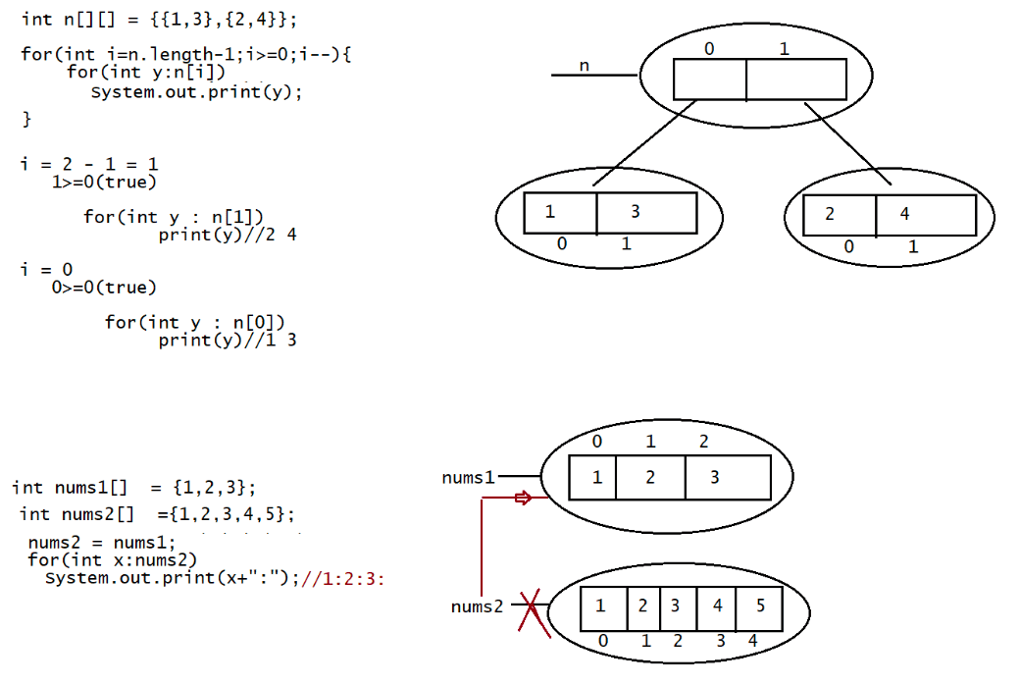
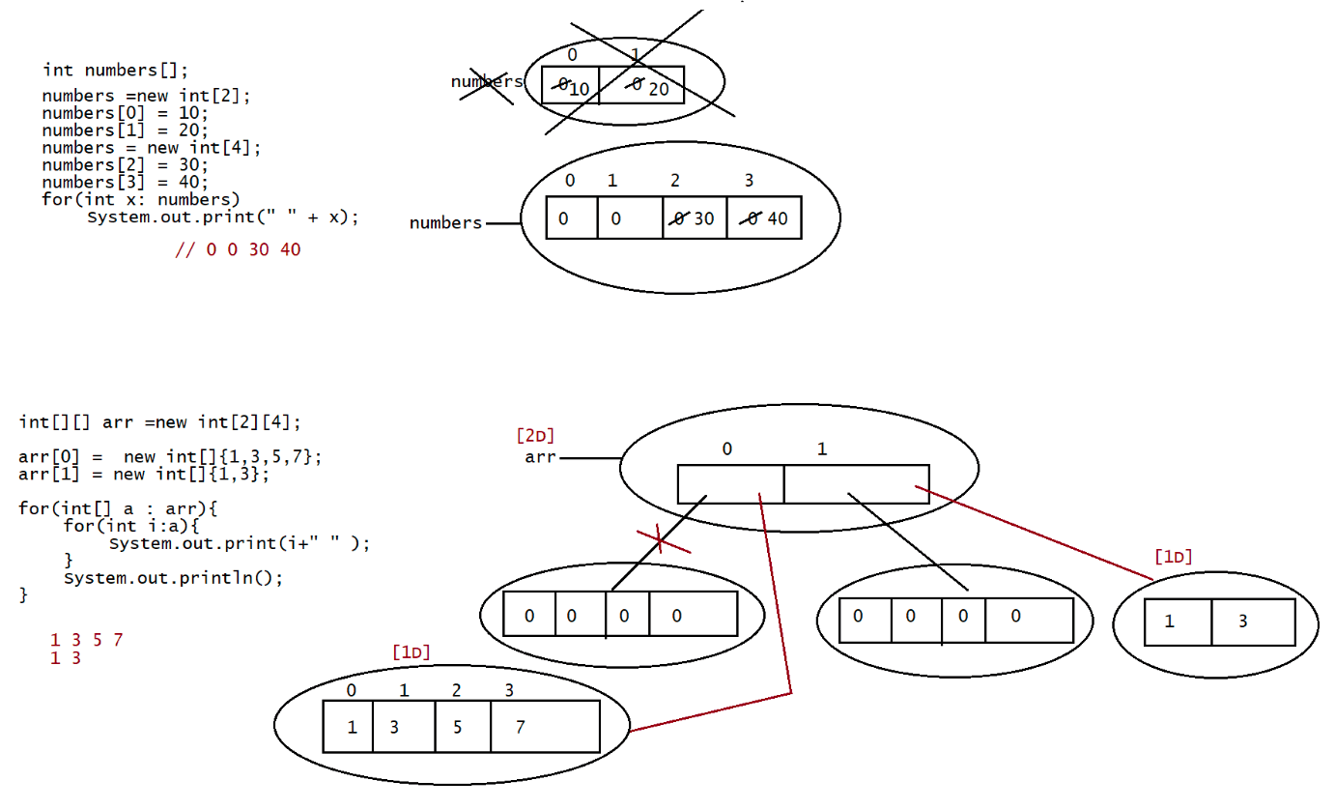
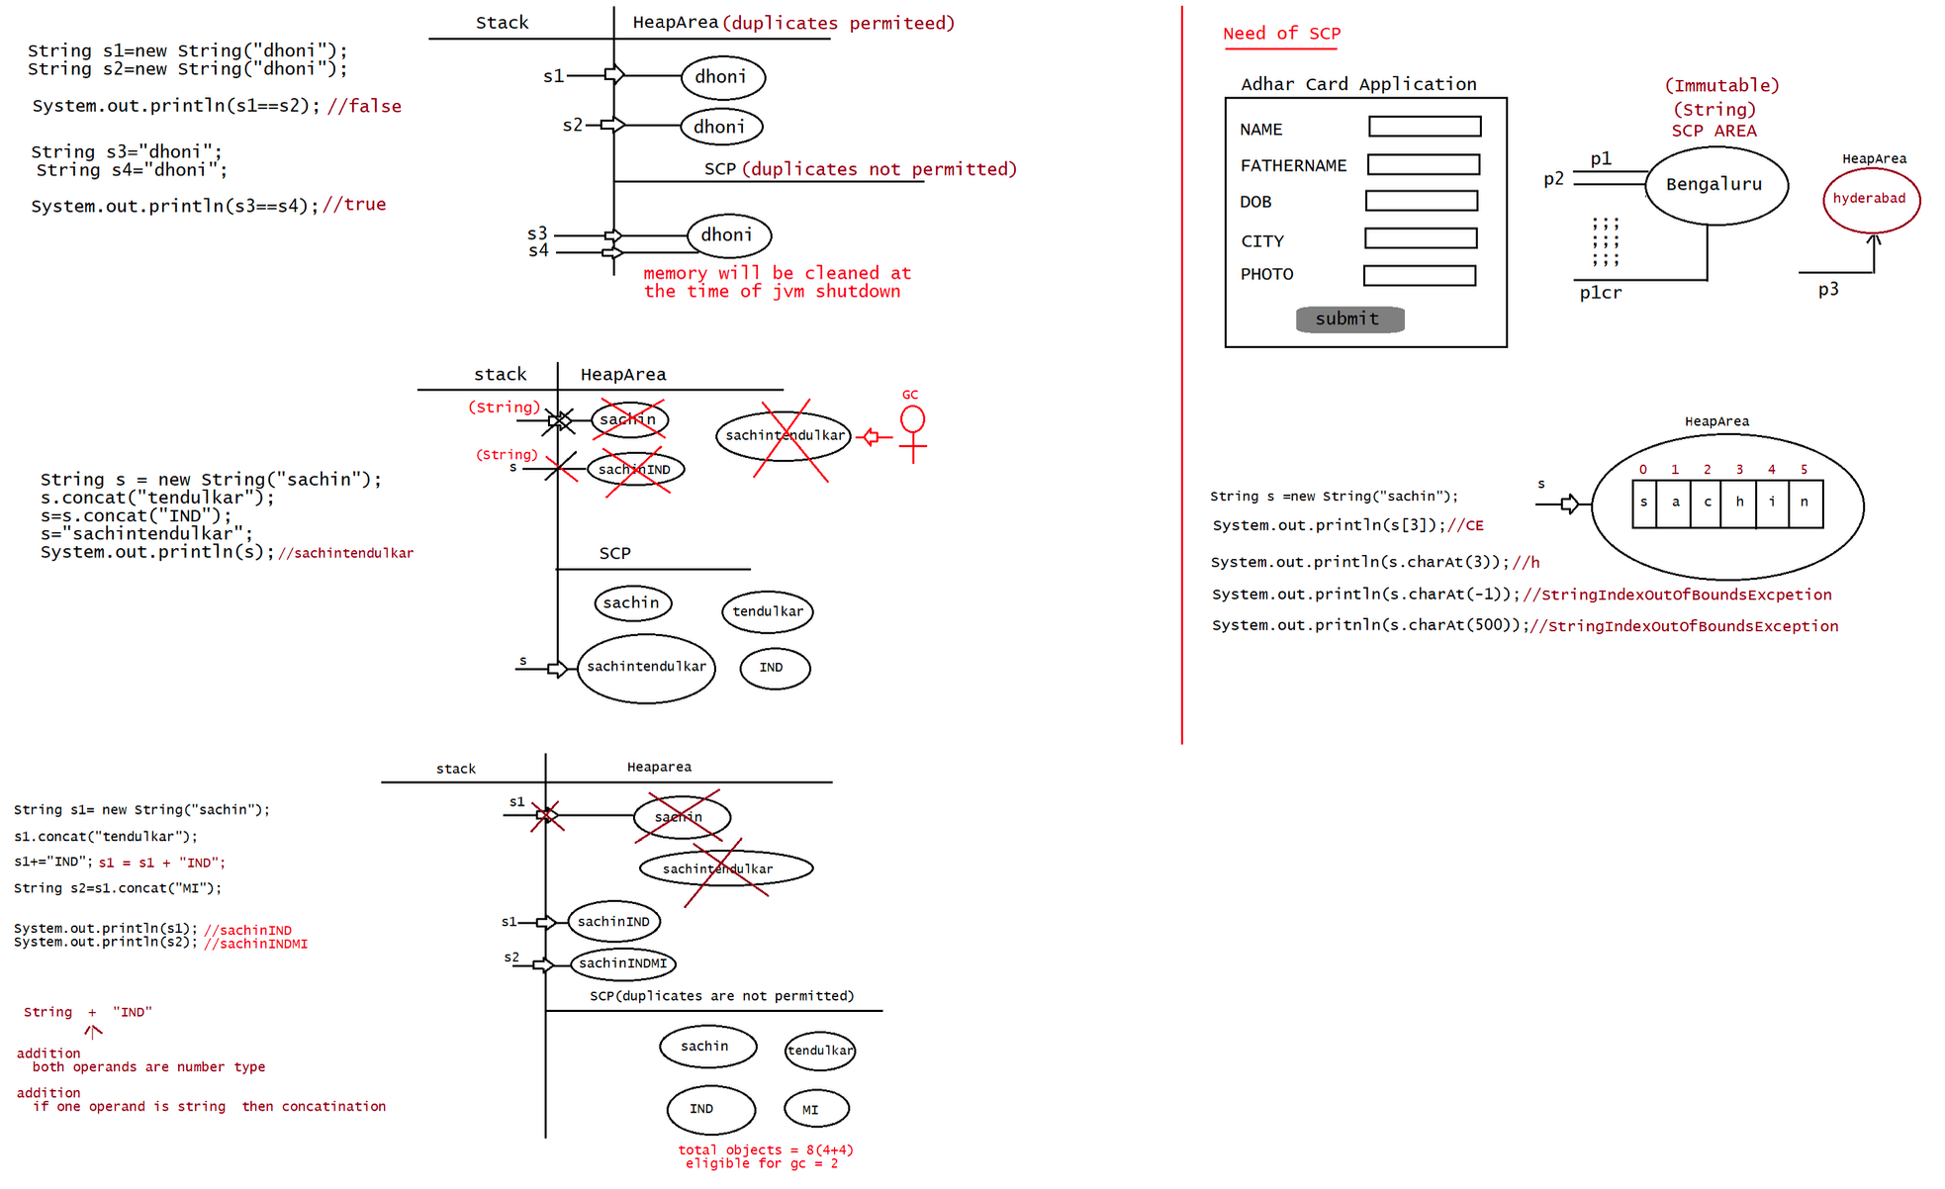
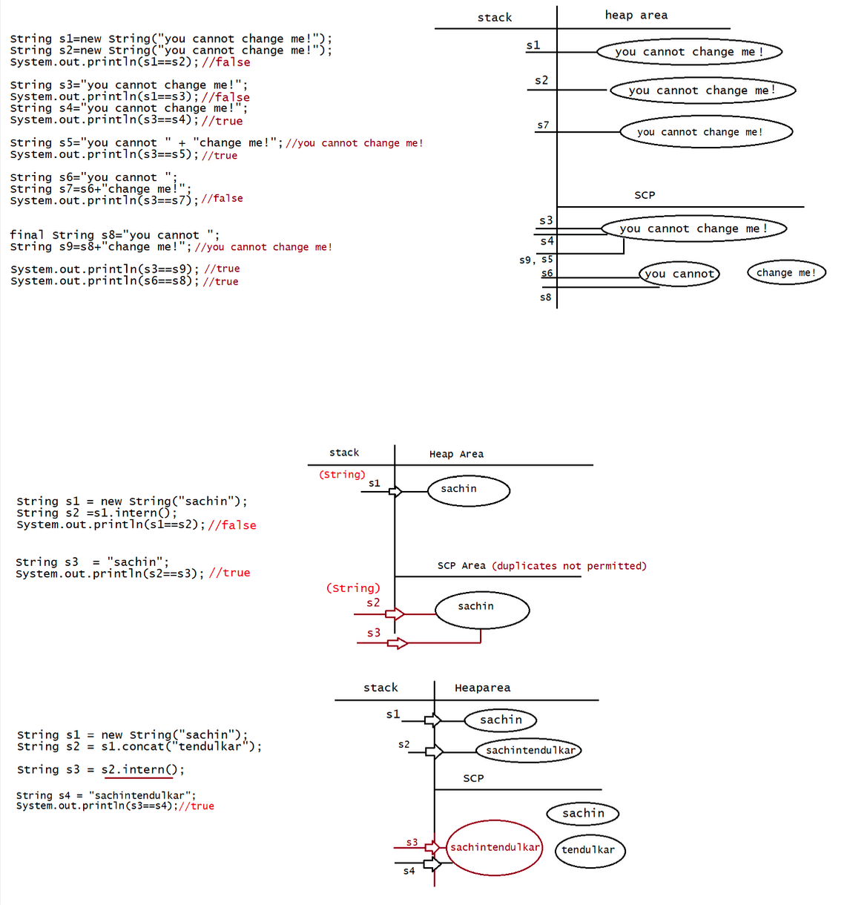

026 String in Java and Mutable String

Methods of String
=================
1.public char charAt(int index)
2.public String concat(String str)
3.public boolean equals(Object o)
4.public boolean equalsIgnoreCase(String s)
5.public String substring(int begin)
6.public String substring(int begin,int end)
7.public int length()
8.public String replace(char old,char new)
9.public String toLowerCase()
10.public String toUpperCase()
11.public String trim()
12.public int indexOf(char ch)
13.public int lastIndexOf(char ch)
3.public boolean equals(Object o)
It is used for Content Comparison,In String class equals() method is
Overriden to check the content of the object
4.public boolean equalsIgnoreCase(String s)
It is used for Content Comparison without comparing the case.
eg#1.
public class Test {
public static void main(String[] args) {
String s ="java";
System.out.println(s.equals("JAVA"));//false
System.out.println(s.equalsIgnoreCase("JAVA"));//true
}
}
Assignment
==========
credentials(gmail)
username:nitin@ineuron.ai(not case sensitive)
password :************(case sensitive)
5.public String substring(int begin)
It gives the String from the begin index to end of the String.
String s="Ineeuron";
System.out.print(s.substring(2));//searching from 2 to end of the string
6.public String substring(int begin,int end)
It gives the String from the begin index to end-1 of the String.
String s="Ineeuron";
System.out.print(s.substring(2,6));//searching from 2 to 5 will happen
eg#1.
public class Test {
public static void main(String[] args) {
String s ="sachinINDMI";
System.out.println(s.length());
System.out.println();
System.out.println(s.substring(9));System.out.println(s.substring(0,8));
System.out.println(s.substring(0,9));
}
}
8.public String replace(char old,char new)
String s="ababab";
System.out.print(s.replace('a','b')); //bbbbbb
eg#1.
public class Test {
public static void main(String[] args) {
String name ="sbchin";
System.out.println(name.replace('b','a'));//sachin
String data = "ababab";
System.out.println(data.replace('a','b'));//bbbbbb
}
}
9. public String toLowerCase()
10. public String toUpperCase()
eg:
public class Test {
public static void main(String[] args) {
String name ="sAchIn";//mixedCase
System.out.println(name.toUpperCase());//SACHIN
System.out.println(name.toLowerCase());//sachin
}
}
11. public String toString();
toString() on the reference
Note: When ever we print any reference,by default JVM will call
eg: System.out.println(name);
System.out.pritnln(name.toString());
eg#1.
//userdefined class
class Student{
String name = "sachin";
int id = 10;
}
public class Test {
public static void main(String[] args) {
Student std = new Student();
System.out.println(std);//Student@HexaDecimalValue
System.out.println(std.toString());////Student@HexaDecimalValue
System.out.println();
String name =new String("dhoni");
System.out.println(name);//dhoni
System.out.println(name.toString());//dhoni
}}
11.public String trim()
To remove the blank spaces present at the begining and end of string
but not the
blank spaces present at the middle of the String.
eg#1.
public class Test {
public static void main(String[] args) {
String name = "Sachin IND";
System.out.println(name.length());//10
System.out.println(name.trim());//Sachin IND
System.out.println();
String state = " Karnataka ";
System.out.println(state.length());//13
System.out.println(state.trim());//Karnataka
}
}
12.public int indexOf(char ch)
It returns the index of 1st occurance of the specified character if the
specified
character is not available then it returns -1.
String s="sachinramesh";
System.out.print(s.indexOf('a'));//1
System.out.print(s.indexOf('z'));//-1
13.public int lastIndexOf(char ch)
It returns the index of last occurance of the specified character if
the specified
character is not available then it returns -1.
String s="sachinramesh";
System.out.print(s.lastIndexOf('a'));//7
System.out.print(s.lastIndexOf('z'));//-1
eg#1.
public class Test {
public static void main(String[] args) {
String name = "hyderAbbasbengaluru";
System.out.println();
System.out.println(name.indexOf('A'));//5
System.out.println(name.indexOf('a'));//8
System.out.println();
System.out.println(name.indexOf('b'));//6
System.out.println(name.lastIndexOf('b'));//10
System.out.println();
System.out.println(name.lastIndexOf('Z'));//-1}
}
Predict the output
===================
Q>
String s1="sachin"; // s1,s3 -> sachin (scp)
String s2=s1.toUpperCase(); // s2->SACHIN(heap area)
String s3=s1.toLowerCase();
System.out.print(s1==s2);//false
System.out.print(s1==s3);//true
Q>
String s1="sachin"; String s2=s1.toString();
System.out.print(s1==s2);//true
// s1,s2-> sachin (SCP)
Q>
String s1=new String("sachin");
String s2=s1.toString();
String s3=s1.toUpperCase();
String s4=s1.toLowerCase();
String s5=s1.toUpperCase();
String s6=s1.toLowerCase();
System.out.print(s1==s6);//true
System.out.print(s3==s5);//false
final vs Immutability
=====================
=> final is a modifer applicable for variables, where as immutability is applicable
only for Objects.
=> If reference variable is declared as final,it means we cannot perform
reAssignment for the reference variable,
it doesnot mean we cannot perform any change in that object.
=> By declaring a reference variable as final, we wont get immutablity nature.
=> final and Immutablity is different concept.
eg:: final StringBuilder sb=new StringBuilder("sachin");
sb.append("tendulkar");
System.out.println(sb);
sb=new StringBuilder("dhoni"); //CE::Cannot assign a value to final
variable
Note::
final variable(valid),
final object(invalid),
immutable variable(invalid)
immutable object(valid)
StringBuilder,StringBuffer are by default mutable.
All Wrapper classes(Byte,Short,Long,Integer,Float,Double,Boolean,Character) are by
Default Immutable.
Mutable -> can be changed
Immutable => can't be changedStringBuffer
===========
1. If the content will change frequently then it is not recomonded to go for
String object becoz for every new
change a new Object will be created.
2. To handle this type of requirement, we have StringBuffer/StringBuilder
concept
Constructors of StringBuffer
=======================
1.StringBuffer sb=new StringBuffer();
creates a empty StringBuffer object with default intital capacity of
"16".
Once StringBuffer reaches its maximum capacity a new StringBuffer Object
will be created
new capacity = (currentcapacity+1) * 2;
eg1::StringBuffer sb = new StringBuffer();
System.out.println(sb.capacity());//16
sb.append("abcdefghijklmnop");
System.out.println(sb.capacity());//16
sb.append('q');
System.out.println(sb.capacity());//34
2. StringBuffer sb=new StringBuffer(initalCapacity);
It creates an Empty String with the specified inital capacity.
eg1::StringBuffer sb = new StringBuffer(19);
System.out.println(sb.capacity());//19
3. StringBuffer sb=new StringBuffer(String s);
It creates a StringBuffer object for the given String with the capacity =
s.length() + 16;
eg1::StringBuffer sb = new StringBuffer("sachin");
System.out.println(sb.capacity());//22
Important methods of StringBuffer/StringBuilder
===============================================
a. public int length()
b. public int capacity()
c. public char charAt(int index)
d. public void setCharAt(int index,char ch)
==================================================
e. public StringBuffer append(String s)
f. public StringBuffer append(int i)
g. public StringBuffer append(long l)
h. public StringBuffer append(boolean b)
i. public StringBuffer append(double d)
j. public StringBuffer append(float f)
k. public StringBuffer append(int index,Object o)
===================================================
l. public StringBuffer insert(int index,String s)
m. public StringBuffer insert(int index,int i)
n. public StringBuffer insert(int index,long l)
o. public StringBuffer insert(int index,double d)
p. public StringBuffer insert(int index,boolean b)
q. public StringBuffer insert(int index,float f)
r. public StringBuffer insert(int index,Object o)=================================================
public StringBuffer delete(int begin,int end)
public StringBuffer deleteCharAt(int index)
public StringBuffer reverse()
public void setLength(int Length)
public void trimToSize()
public void ensureCapacity(int capacity)
eg::
StringBuilder sb = new StringBuilder("sachinrameshtendulkar");
System.out.println(sb.length());//21
System.out.println(sb.capacity());//21 + 16 = 37
System.out.println(sb.charAt(20));//'r'
System.out.println(sb.charAt(100));//StringIndexOutOfBoundsException
eg::
StringBuffer sb1 =new StringBuffer("kohlianushka");
sb1.setCharAt(5,'A');
System.out.println(sb1);//kohliAnushka

Q> int data[] = {2010,2013,2014,2015,2014};
int key = 2014;
int count=0;
for(int e:data){
if(e!=key){
continue;
count++;
}
}
System.out.println(count+" found");
What is the result?
A. Compilation fails
B. 0 found
C. 1 found
D. 3 found
Answer: A (unreachable code becoz of continue)
Q>
String[] arr = {"A","B","C","D"};
for(int i =0;i< arr.length;i++){
System.out.print(arr[i]+" " );
if(arr[i].equals("C"))
continue;
System.out.println("Work done");
break;
}
A. A B C Work done
B. A B C D Work done
C. A Work done
D. Compilation fails
arr[0] = "A", arr[1]= "B", arr[2] ="C", arr[3]="D"
i =0, arr.length=4
0<4(true)
A Work done
Answer: C
Q>
String[] str = new String[2];
int idx = 0;
for(String s: str){
str[idx].concat(" element " + idx);
idx++;
for(idx =0;idx<str.length;idx++){
System.out.print(str[idx]);
}
}
A. element 0
element 1
B. null element 0
null element 1
C. null
null
D. NullPointer Excpetion is thrown at runtimeAnswer: D
Q>
String[][] arr = {{"A","B","C"},{"D","E"}};
for(int i =0;i< arr.length;i++){
for(int j=0;j<arr[i].length;j++){
System.out.print(arr[i][j]+" " );
if(arr[i][j].equals("B"))
break;
}
continue;
}
A. A B C
B. A B C D E
C. A B D E
D. Compilation fails
Answer: C
Q>
public class Test {
public static void main(String[] args) {
StringBuffer sb =new StringBuffer("java");
String s = "java";
if (sb.toString().equals(s.toString()))
System.out.println("Match -1");
else if(sb.equals(s))
System.out.println("Match -2");
else
System.out.println("No Match");
}
}
A. Match -1
B. Match -2
C. No Match
D. Null Pointer excpetion at runtime
Answer: A
Q> int[] a =new int[]? What is the array size ?
A. 0
B. 4
C. 1
D. Can't find it results in Compiletime error
E. exception at the runtime
Answer: D
Q> int[] a =new int[0]; will the code compile?
A. yes
B. no
Answer: A
Q> int[] a=new int[-5];? What it the size of the array?
A. 5
B. -5
C. 0
D. 1F. Compilation error as size is negative
G. NegativeArraySizeException is occured
H. ArrayIndexOutofBoundsException is occured
Answer: G
ArrayIndexOutofBoundsException => Array is already created and if we go out of
index while reading or writing to array we get.
NegativeArraySizeException is occured => During creation of an Array it would
result.
Q> Consider below code:
public class Test {
public static void main(String[] args) {
System.out.println("ONE");
}
public static void main(Integer[] args) {
System.out.println("TWO");
}
public static void main(byte [] args) {
System.out.println("THREE");
}
}
java Test 10
A. TWO
B. ONE
C. THREE
D. Compilation Error
What will be the result if Test class is executed by below command?
Answer: B
Q>
public class Test {
public static void main(String[] args) {
if ((isItSmall(3)) || (isItSmall(7))) {//line-3
System.out.println("Result is true");
}
if ((isItSmall(6)) || (isItSmall(9))) {//line-6
System.out.println("Result is true");
}
}
public static boolean isItSmall(int i) {
if (i < 5) {
System.out.println("i < 5");
return true;
} else {
System.out.println("i >= 5");
return false;
}
}
}
What is the result?
A. Compilation Error at line 3
B. Compilation Error at line 6
C. i<5
Result is true
D. i<5
Result is truei>=5
Result is true
E. i<5
Result is true
i>=5
i>=5
Result is true
F. i<5
Result is true
i>=5
i>=5
Answer: F
Q>
class Feline {
public static void main(String[] args) {
Long x = 42L;
Long y = 44L;
System.out.print(" " + 7 + 2 + " ");// 72
System.out.print(foo() + x + 5 + " ");//foo425
System.out.println(x + y + foo());//86foo
}
static String foo() { return "foo"; }
}
What is the result?
A. 9 foo47 86foo
B. 9 foo47 4244foo
C. 9 foo425 86foo
D. 9 foo425 4244foo
E. 72 foo47 86foo
F. 72 foo47 4244foo
G. 72 foo425 86foo
H. 72 foo425 4244foo
Answer: G

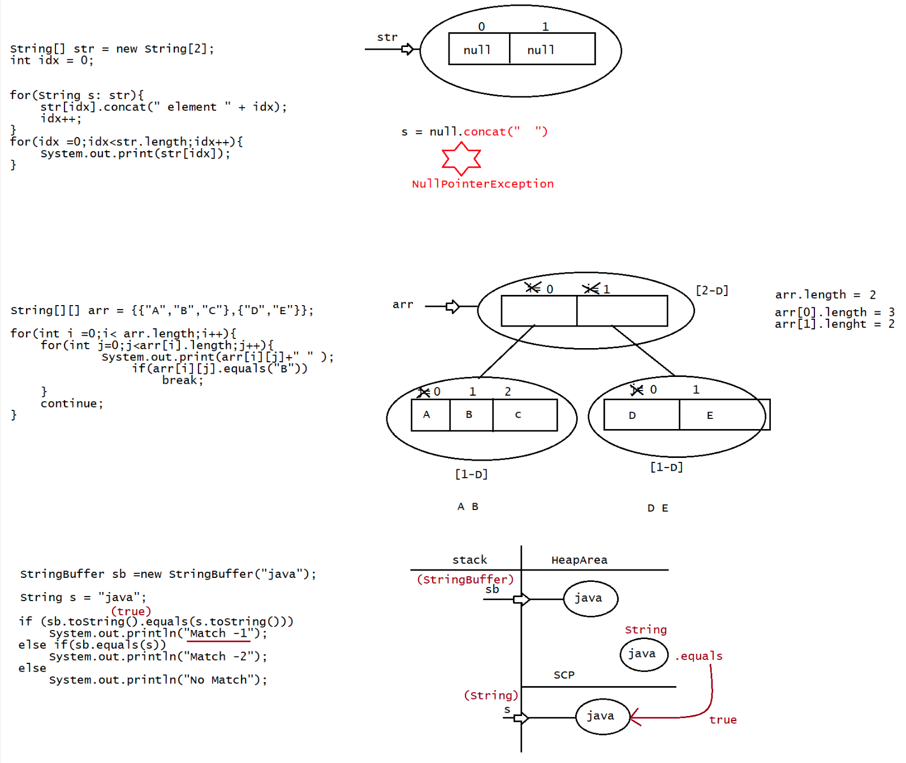
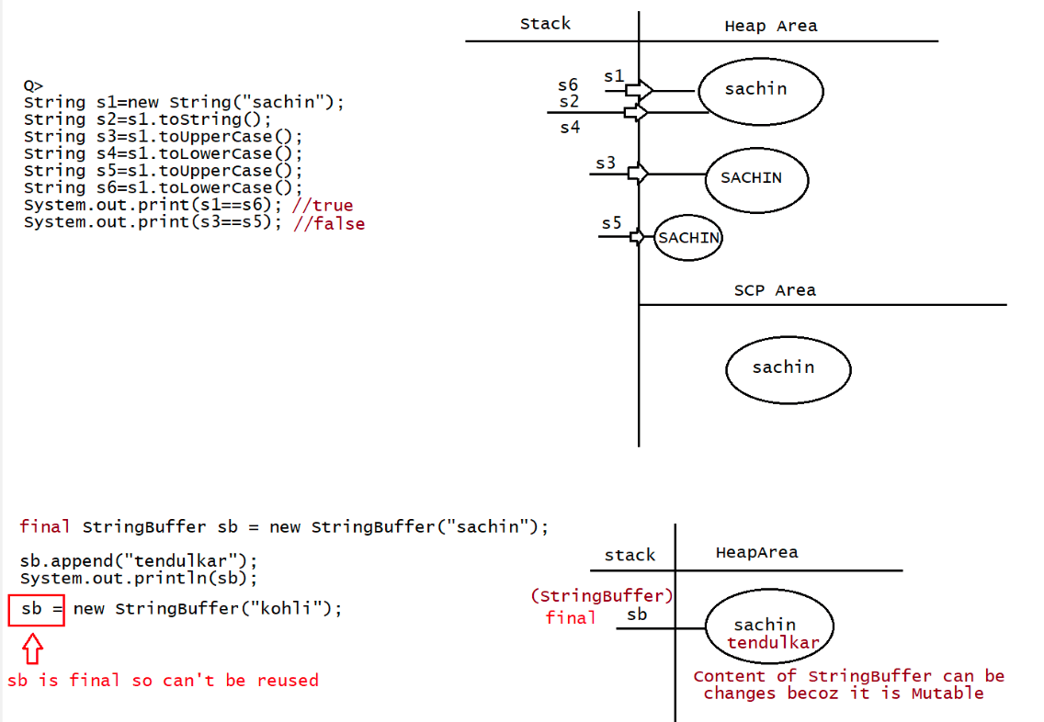

027 DOUBT
contact details:
haider :syedhyder@ineuron.ai
nitin : nitin@ineuron.ai
Q>
Doubts:
1. When we create a String object with string buffer or builder will a copy be
created in string pool too, if so how does it become mutable.
My understanding of String being immutable is because they are created in SCP
area of memory too.
String,WrapperClass-> Immutable
String s = "sachin"; => SCP area
String s=new String("kohli"); => SCP, Heap area(s)
StringBuffer,StringBuilder => mutable
StringBuffers sb =new StringBuffer("dhoni"); ===> SCP, Heap
area(sb)
String s =new String(sb);====> HeapArea(s)
2. If prewritten code that we use are API, why Arrays are not called as API but
class
Every class which we are using we call it as "API" only,but while talking we
say as class.
3. static and non static variable
are called "static variables".
static variable => a variable which is declared using static keyword
eg: static int a = 10;
non static variable => a variable which is not declared using static
keyword are called "instance variables".
eg: int a =100;
4. How to create temporory Array and assign existing arrays values?
int a[] =new int[5];
int b[] = {10,20,30};
a=b;
5. public int lastIndexOf(char ch)
Does this method search the character in the string in reverse order(last to
first)?
searching from last index to first index
6. Sir, i have confusion on return statement.....can u explain it
class Demo
{
public int m1(){
System.out.println("hello");
return 10;
}
public void m2(){
System.out.println("hiee");
return;
}
}public class Test {
public static void main(String[] args) {
Demo d = new Demo();
int result=d.m1();
System.out.println(result);
d.m2();
}
}
Q> Ananomyous Array
public class Test {
public static void main(String[] args) {
display(new int[]{10,20,30,40,50});
}
static void display(int[] arr){
for(int ele:arr)
System.out.println(ele);
}
}
Q>
{
class Demo
Demo(){
}
System.out.println("constructor called");
}
public class Test {
Demo d = new Demo();
Test(){
System.out.println("Test class Constructor");
}
public static void main(String[] args) {
Test t =new Test();
}
}
Q>1 plz check at line 1, new object will create on heap ?
Q>2 sir can you explain at what time object will create ,at the of classloading?
Q>
String s1 = new String("Test1");
String s2 = new String("Test1");
System.out.println(s1.equals(s2)); //output true
StringBuffer s3 = new StringBuffer("Test1");
StringBuffer s4 = new StringBuffer("Test1");
System.out.println(s3.equals(s4)); //output false
Q>
String s1 = new String("Nitin");//SCP(Nitin) and in heaparea(s1)String s2 = "Nitin";//SCP s2,s3-> Nitin
String s3 = "Nitin";
String s4 = "nitin";//SCP s4->nitin
System.out.println("Value is: "+ s1==s2); //false
System.out.println("Value is: "+ s2==s3); // true
System.out.println("Value is: "+ s3==s4); //false
Q>
String s1 = new String("Nitin");
String s2 = "Nitin";
System.out.println("Value is: "+ s1==s2)//false
Q>
StringBuffer sb=new StringBuffer("sachin");//new object created in heap(sachin)and
SCP(sachin)
sb.append("tendulkar");//sb in heap area now pointing to sb-> sachin tendulkar
Q)will the existing object in SCP also gets modified to sachin tendulkar?
Ans. no
Q> sir in int[] array if we give char value it is showing compile time error Hyder
sir said
compiling
it will give run time error called array store exception. but it is not only
int[] a = {'a','b','c'};
Q>sir, in Inheretence only we create object reference parent name or another also
we can write ?
please explain?
Ans. yes
eg: Parent ref =new Child(); //only in inheritance.
Q> System.out.println();
Here out points to null then how it can access println() method?
out => refers to the Object of PrintStream(java.io)
Q> String name = new String("sachin");
name-> "sachin" (heap area)
========================
sachin(SCP)
"memory will be deallocated during jvm shutdown"

028 Mutable String and String programming

StringBuffer
===========
1. If the content will change frequently then it is not recomonded to go for
String object becoz for every new
change a new Object will be created.
2. To handle this type of requirement, we have StringBuffer/StringBuilder
concept
f. public StringBuffer append(int i)
g. public StringBuffer append(long l)
h. public StringBuffer append(boolean b)
i. public StringBuffer append(double d)
j. public StringBuffer append(float f)
k. public StringBuffer append(int index,Object o)
append method is overloaded method, methodName is same but change in the argument
type.
eg::
StringBuffer sb = new StringBuffer();
sb.append("PI value is :: ");
sb.append(3.1414);
sb.append(" This is exactly ");
sb.append(true);
System.out.println(sb);// PI value is ::3.1414 This is exactly true
Overloaded methods
===================
l. public StringBuffer insert(int index,String s)
m. public StringBuffer insert(int index,int i)
n. public StringBuffer insert(int index,long l)
o. public StringBuffer insert(int index,double d)
p. public StringBuffer insert(int index,boolean b)
q. public StringBuffer insert(int index,float s)
r. public StringBuffer insert(int index,Object o)
To insert the String at the specified position we use insert method
eg::
StringBuffer sb = new StringBuffer("sacin");
sb.insert(3, 'h');
System.out.println(sb);//sachin
sb.insert(6, "IND");
System.out.println(sb);//sachinIND
Methods of StringBuffer
=======================
public StringBuffer delete(int begin,int end)
It deletes the character from specified index to end-1.
public StringBuffer deleteCharAt(int index)
It deletes the character at the specified index.
eg::
StringBuffer sb=new StringBuffer("sachinrameshtendulkar");
sb.delete(6,12);
System.out.println(sb);//sachintendulkar
sb.deleteCharAt(13);System.out.println(sb);//sachintndulkar
public StringBuffer reverse()
It is used to reverse the given String.
eg:: StringBuffer sb=new StringBuffer("sachin");
sb.reverse();
System.out.println(sb);//nihcas
public void setLength(int Length)
It is used to consider only the specified no of characters and remove all the
remaining characters.
eg::
StringBuffer sb=new StringBuffer("sachinramesh");
sb.setLength(6);
System.out.println(sb);//sachin
public void trimToSize()
This method is used to deallocate the extra allocated free memory such that
capacity
and size are equal.
eg::
StringBuffer sb = new StringBuffer(1000);
System.out.println(sb.capacity());//1000
sb.append("sachin");
System.out.println(sb.capacity());//1000
sb.trimToSize();
System.out.println(sb);//sachin
System.out.println(sb.capacity());//6
public void ensureCapacity(int capacity)
It is used to increase the capacity dynamically based on our requirement.
eg::
StringBuffer sb = new StringBuffer();
System.out.println(sb.capacity());//16
sb.ensureCapacity(1000);
System.out.println(sb.capacity());//1000
EveryMethod present in StringBuffer is synchronized, so at a time only one thread
can are allowed to operate on StringBuffer Object, it would increase the waiting
time of the threads it would
create performance problems, to overcome this problem we should go for
StringBuilder.
StringBuilder(1.5v)
StringBuilder is same as StringBuffer(1.0V) with few differences
StringBuilder
No methods are synchronized
At at time more than one thread can operate so it is not ThreadSafe.
Threads are not requried to wait so performance is high.
Introduced in jdk1.5 versionString vs StringBuffer vs StringBuilder
======================================
String => we opt if the content is fixed and it wont change
frequently
StringBuffer => we opt if the content changes frequently but ThreadSafety is
required
StringBuilder => we opt if the content changes frequently but ThreadSafety is not
required
MethodChaining
=============
only, hence after
chaining.
Most of the methods in String,StringBuilder,StringBuffer return the same type
applying method on the result we can call another method which forms method
eg::
StringBuffer sb = new StringBuffer();
sb.append("sachin").insert(6, "tendulkar").reverse().append("IND").delete(0,
4).reverse();
System.out.println(sb);
eg#2.
class TestApp {
public static void main(String[] args) {
String name ="sachin";
String data = name.toUpperCase();
int count = data.length();
System.out.println(count);
//method chaining
System.out.println(name.toUpperCase().length());
StringBuffer sb = new StringBuffer("virat");
//method chaining
sb.append("kohli").
insert(10,"anushka").
reverse().
append("IND").
insert(sb.length(),"RCB").
reverse().delete(0,6);
System.out.println(sb);
StringBuffer sb1 =new StringBuffer("dhoni");
sb1.length().append("CSK");//CE:int can't be dereferenced
}
}

Q> String str =" ";
str.trim();
System.out.println(str.equals("")+ " " + str.isEmpty());
What is the result?
A. true false
B. true true
C. false true
D. false false
Answer: D(becoz of immutable)
Q> String s = "SACHIN TENDULKAR";
int len= s.trim().length();
System.out.println(len);
What is the result?
A. 10
B. 9
C. 8
D. compilation fails
E. None of the above
Answer: E(16 is the length)
Q> String s= "Hello world";
s.trim();
int i = s.indexOf(" ");
System.out.println(i);
What is the result?
A. Exception at runtime
B. -1
C. 5
D. 0
Answer: C
Q> String s1= "Java";
String s2=new String("java");
//line-1
{
System.out.println("equal");
}else{
System.out.println("not equal")
}
To print equal which code fragment should be inserted?
A. String s1=s2;
if(s1==s2)
B. if(s1.equalsIgnoreCase(s2))
C. String s3= s2;
if(s3.equalsIgnoreCase(s2))
D. if(s1.toLowerCase() == s2.toLowerCase())
Answer: A, B, C
Q> System.out.print("" == "");
System.out.print(" ");System.out.print("A"=="A");
System.out.print("a==A");
A. == A=A a=A
B. compile time error
C. true true a==A
d. false true true
E. true true false
F. None of the above
Answer: C
What will be the result of compiling and executing Test class?
public class Test {
public static void main(String[] args) {
String str = "Java Rocks!";
System.out.println(str.length() + " : " + str.charAt(10));
}
}
A. 11:!
B. Exception is thrown at RunTime
C. 11:s
D. CompilationError
Answer: A
What will be the result of compiling and executing Test class?
public class Test {
public static void main(String[] args) {
String s1 = "OcA";
String s2 = "oCa";
System.out.println(s1.equals(s2));
}
}
A. true
B. false
C. compilation error
D. None of the above
Answer: B
What will be the result of compiling and executing Test class?
public class Test {
public static void main(String[] args) {
String fName = "James";
String lName = "Gosling";
System.out.println(fName = lName);
}
}
A. CompilationError
B. true
C. false
D. None of the above
Answer: D(Gosling will be printed)
What will be the result of compiling and executing Test class?
public class Test {public static void main(String[] args) {
String str = "Good"; //Line 3
change(str); //Line 4
System.out.println(str); //Line 5
}
private static void change(String s) {
s.concat("_Morning"); //Line 9
}
}
A. Good
B. _Morning
C. Good_Morning
D. None of the above
Answer: A
What will be the result of compiling and executing Test class?
public class Test {
public static void main(String[] args) {
StringBuilder sb = new StringBuilder("Good"); //Line 3
change(sb); //Line 4
System.out.println(sb); //Line 5
}
private static void change(StringBuilder s) {
s.append("_Morning"); //Line 9
}
}
A. Good
B. _Morning
C. Good_Morning
D. None of the above
Answer: C
Q>
What will be the result of compiling and executing Test class?
public class Test {
public static void main(String[] args) {
String str1 = new String("Core");
String str2 = new String("CoRe");
System.out.println(str1 = str2);
}
}
A. true
B. false
C. Core
D. CoRe
Answer: D
What will be the result of compiling and executing Test class?
public class Test {
public String toString() {
return "TEST";
}public static void main(String[] args) {
Test obj = new Test();
System.out.println(obj);
}
}
A. TEST
B. Output contains some string @ symbol
C. Excpetion is thrown at runtime
D. Compilation Error
Answer: A
Consider below code:
//Test.java
public class Test {
public static void main(String[] args) {
String s1 = "OCAJP";
String s2 = "OCAJP" + "";//"OCAJP"
System.out.println(s1 == s2);
}
}
A. OCAJP
B. true
C. false
D. CompilationError
What will be the result of compiling and executing Test class?
Answer: B
Consider below code:
//Test.java
public class Test {
public static void main(String[] args) {
final String fName = "James";
String lName = "Gosling";
String name1 = fName + lName;
String name2 = fName + "Gosling";
String name3 = "James" + "Gosling";
System.out.println(name1 == name2);
System.out.println(name2 == name3);
}
}
A. true
true
B. true
false
C. false
false
D. false
true
What will be the result of compiling and executing Test class?
Answer: D

public class CopyStrings {

public static void main(String[] args)
{
String s1="iNeuron";

String s2="";

for(int i=0;i<s1.length();i++)
{
s2=s2+s1.charAt(i);
}
System.out.println("First String is "+s1);
System.out.println("Copy of First String "+ s2);
}

}

public class LaunchReverse {

public static void main(String[] args) {
// TODO Auto-generated method stub

String s1="iNeuron";
String s2="";
for(int i=s1.length()-1;i>=0;i--)
{
s2=s2+s1.charAt(i);
}
System.out.println("Original String: "+s1);
System.out.println("After Reversing: "+s2);

//ineuron java --> avaj norueni

String str1="ineuron java";
String str2="";

String sarr[]=str1.split(" ");

for(String elem: sarr)
{
for(int i=elem.length()-1;i>=0;i--)
{
str2=str2+elem.charAt(i);
}
str2=str2 +" ";

}
System.out.println(str2);// norueni avaj

// ineuron java ->java ineuron

String ss="ineuron java";
String ss2="";
String ar[]=ss.split(" ");
for(int i=ar.length-1; i>=0;i--)
{
ss2=ss2+ar[i]+" ";
}
System.out.println(ss);
System.out.println(ss2);

}

}
import java.util.Scanner;

public class LaunchUtoLAndLtU {

public static void main(String[] args) {
// TODO Auto-generated method stub

char ch='a';//97-32= 65/A
System.out.println(ch);
ch=(char) (ch-32);
System.out.println(ch);

Scanner hyder=new Scanner(System.in);
System.out.println("Please enter the string value to be converted to upper case");
String s1=hyder.nextLine();

String s2="";

for(int i=0;i<s1.length();i++)
{
s2=s2+(char)(s1.charAt(i)-32);
}

//String str=""+'I';
System.out.println(s1);
System.out.println(s2);

String str1="HYDER";
System.out.println(str1);

String str2="";

for(int i=0;i<str1.length();i++)
{
str2=str2+(char)(str1.charAt(i)+32);
}

System.out.println(str2);

//To convert InEUrOn into iNeuRoN

String ss="InEUrOn";
String ss2="";

for(int i=0;i<ss.length();i++)
{
if(ss.charAt(i)>='a' && ss.charAt(i)<='z')
{
ss2=ss2+(char)(ss.charAt(i)-32);
}
else
{
ss2=ss2+(char)(ss.charAt(i)+32);
}

}
System.out.println(ss);
System.out.println(ss2);

}

}
contact details
hyder: syedhyder@ineuron.ai
nitin : nitin@ineuron.ai
Q>
Given
3. public class Spock {
4. public static void main(String[] args) {
5. int mask = 0;
6. int count = 0;
7. if( ((5<7) || (++count < 10)) | mask++ < 10 ) mask = mask + 1;
8. if( (6 > 8) ^ false) mask = mask + 10;
9. if(!(mask > 1) && ++count > 1) mask = mask + 100;
10. System.out.println(mask + " " + count);
11. }
12. }
Which two are true about the value of mask and the value of count at line 10?
(Choose two.)
A. mask is 0
B. mask is 1
C. mask is 2
D. mask is 10
E. mask is greater than 10
F. count is 0
G. count is greater than 0
count = 0
mask = 2
Answer: C,F
Which of the following declarations are invalid?
1) int[] a=new int[];
2) int[][] a=new int[3][4];
3) int[][] a=new int[3][];
4) int[][] a=new int[][4];
5) int[][][] a=new int[3][4][5];
6) int[][][] a=new int[3][4][];
7) int[][][] a=new int[3][][5];
Answer: 1,4,7(invalid: beocz of dimension missing)
What is the output of this code?
int[] a=new int[3];
System.out.println(a);
System.out.println(a[0]);
A. CE
B. [I@...
0
C. Some problem at the runtime
D. [I@..
null
Answer: B
What is the output of this code?
int[][] a =new int[3][2];
System.out.println(a);System.out.println(a[0]);
System.out.println(a[0][0]);
A. CE
B. [I@...
[[I@...
0
C. Some problem at the runtime
D. [[I@..
[I@...
0
E. D. [[I@..
[I@...
null
Answer: D
Predict the output
int[][] a=new int[2][];
System.out.println(a);
System.out.println(a[0]);
System.out.println(a[0][0]);
A. Compile time error
B. 0
[I@...
0
C. [[I@...
null
0
D. [[I@...
[I@...
0
E.C. [[I@...
null
NullPointerException
Answer: E
For the above code predict how many objects are created and how many are eligible
for garbage collection?
int[][] a=new int[3][2];
a[0]=new int[3];
a[1]=new int[4];
a=new int[4][3];
A. object created = 3
eligible for gc = 3
B. object created = 11
eligible for gc = 6
C. object created = 10
eligible for gc = 5
D.object created = 10
eligible for gc = 10
E. None of the above
Answer: BWhat is the nature of the following code?
class Test {
int[] a; //instance variable -> memory will be created during object creation
and default value by JVM
public static void main(String[] args) {
Test t1=new Test();
System.out.println(t1.a);
System.out.println(t1.a[0]);
}
}
A. Compile Time Error
B. 0
0
C. [I@...
0
D. null
ArrayIndexOutOfBoundsException
E. null
NullPointerException
Answer: E
Q> Here a is declared at instance level
int[] a=new int[3];
System.out.println(obj.a);
System.out.println(obj.a[0])
A. Compile Time Error
B. 0
0
C. [I@...
0
D. null
ArrayIndexOutOfBoundsException
E. null
NullPointerException
Answer: C
Q> Predict the nature of the following code
class Test {
public static void main(String[] args) {
int[] a; //local variable -> can't be used without intialization
System.out.println(a);
System.out.println(a[0]);
}
}
A. Compile Time Error
B. 0
0
C. [I@...
0
D. null
ArrayIndexOutOfBoundsException
E. null
NullPointerException
Answer: A

import java.util.Arrays;

public class LaunchAnagram {

public static void main(String[] args) {
// TODO Auto-generated method stub
String s1="a gentle Man";
String s2="elegant Man";

s1=s1.replace(" ", "");
s2=s2.replace(" ", "");

s1=s1.toLowerCase();
s2=s2.toLowerCase();

char[] ch1=s1.toCharArray();
char[] ch2=s2.toCharArray();

Arrays.sort(ch1);
Arrays.sort(ch2);

if(Arrays.equals(ch1, ch2))
{
System.out.println("It's Anagram");
}
else
{
System.out.println("It's not Anagram");
}

}

}

class Student
{
private int age; //instance variable//Data Member//Fields
private String name; //properties
private String city;

void setAge(int age)
{
this.age=age;
}
int getAge()
{
return age;
}
void setName(String name)
{
this.name=name;
}
String getName()
{
return name;
}
void setCity(String city)
{
this.city=city;
}
String getCity()
{
return city;
}

}
//

public class LaunchEncap {

public static void main(String[] args) {

Student st=new Student();
/*
* st.age=-28; st.name="Xp12XP"; st.city="Bengaluru";
*/
//st.age=-28; error bcz age is private
st.setAge(28);
int age=st.getAge();
System.out.println(age);

st.setName("Hyder");
System.out.println(st.getName());

}

}

public class LaunchPalindrome {

public static void main(String[] args) {
// TODO Auto-generated method stub
String s1="NITIN";
String s2="";

for(int i=s1.length()-1;i>=0;i--)
{
s2=s2+s1.charAt(i);
}
System.out.println(s2);

if(s1.equals(s2))
{
System.out.println("String is palindrome");
}
else
{
System.out.println("String is not palindrome");
}

}

}

public class LaunchPangram {

public static void main(String[] args)
{
// TODO Auto-generated method stub

boolean hyder=false;
String s1="THE QUICK BROWN FOX JUMPS OVER THE LAZY DOG";

s1=s1.replace(" ", "");

char[] ch=s1.toCharArray();

int[] ar=new int[26];

for(int i=0;i<ch.length;i++)
{
int index=ch[i]-65;
ar[index]++; //ar[19]++ --> 0++ --> 1++ --->2
//ar[ch[i]-65]++;
}
for(int i=0; i<ar.length;i++)
{
if(ar[i]==0)
{
System.out.println("It's not pangram");
hyder=true;
}
}
if(hyder==false)
{
System.out.println("It's pangram");
}
}

}
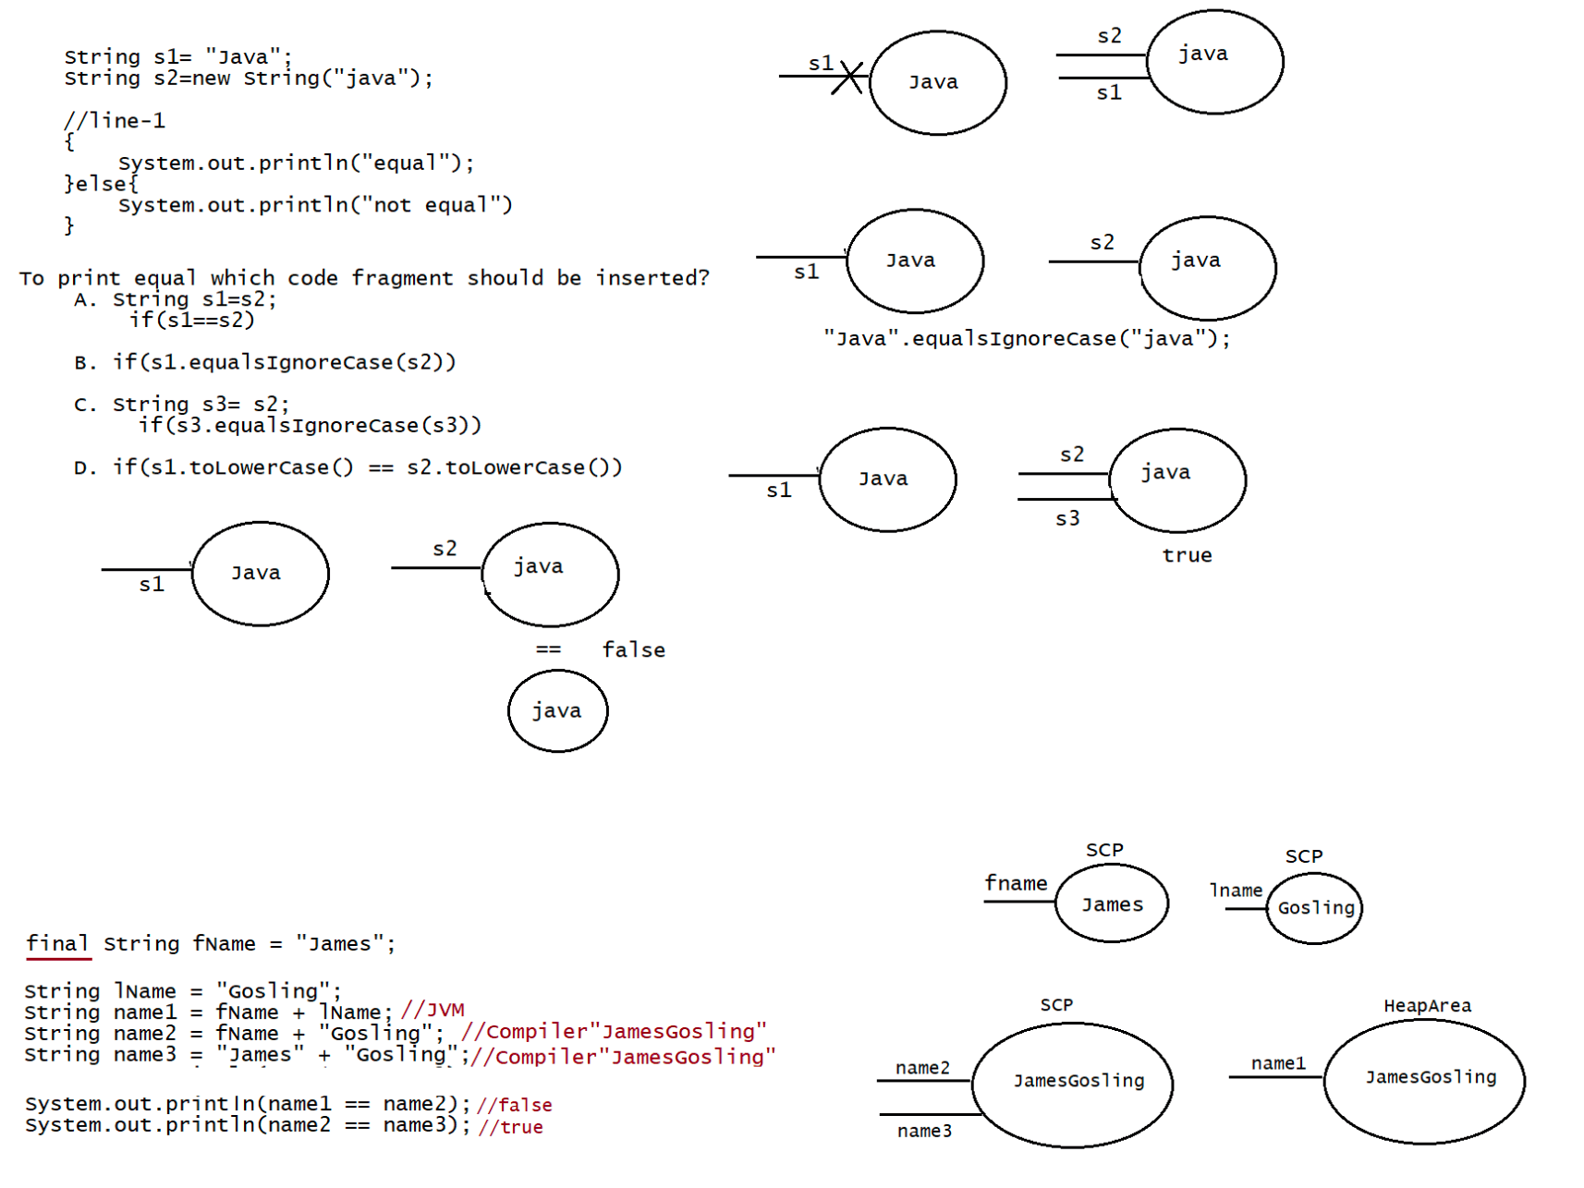
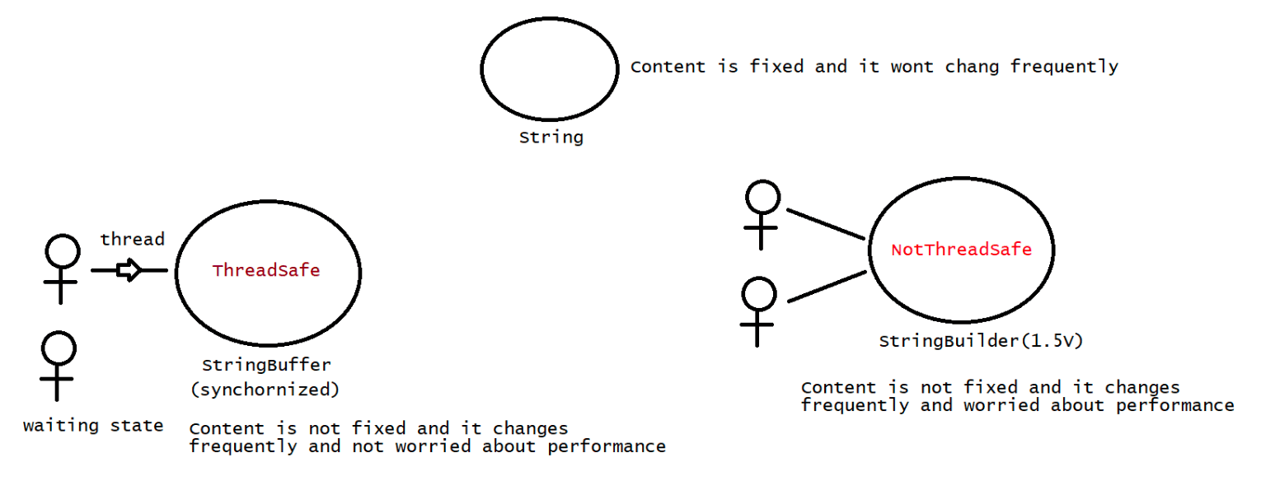
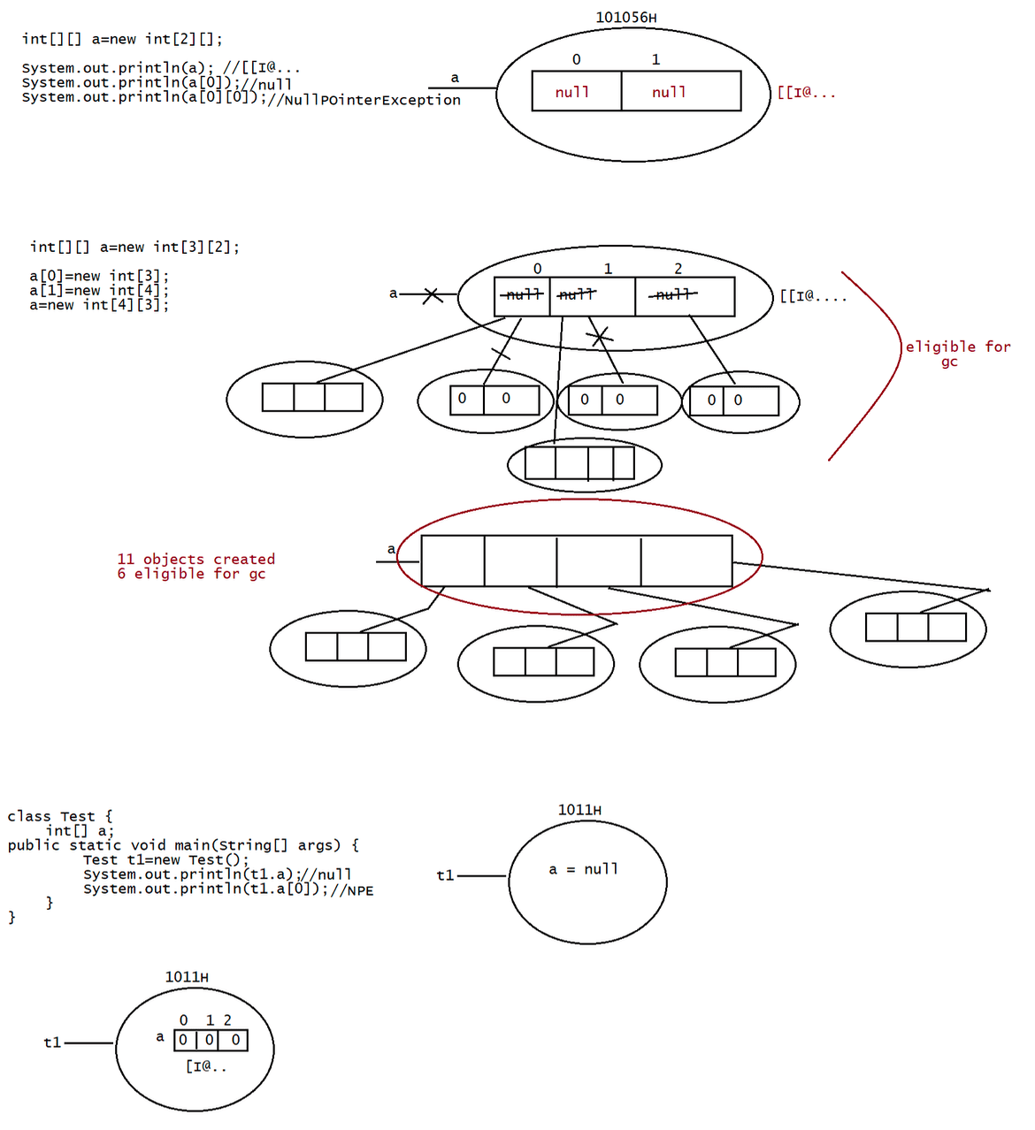
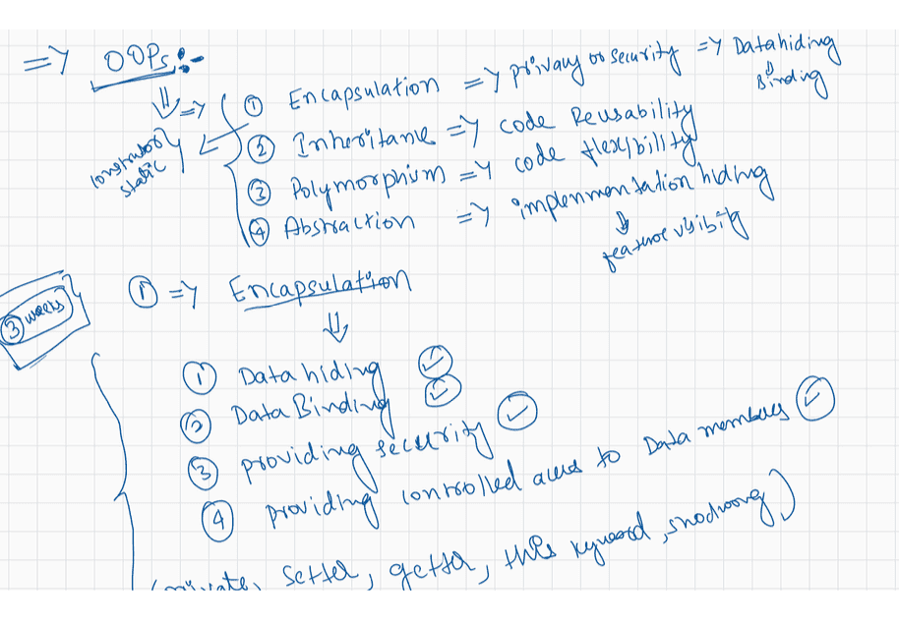

029 String programming, Encapsulation, GitHub Eclipse integration
contact details
hyder: syedhyder@ineuron.ai
nitin : nitin@ineuron.ai
Q>
Given
3. public class Spock {
4. public static void main(String[] args) {
5. int mask = 0;
6. int count = 0;
7. if( ((5<7) || (++count < 10)) | mask++ < 10 ) mask = mask + 1;
8. if( (6 > 8) ^ false) mask = mask + 10;
9. if(!(mask > 1) && ++count > 1) mask = mask + 100;
10. System.out.println(mask + " " + count);
11. }
12. }
Which two are true about the value of mask and the value of count at line 10?
(Choose two.)
A. mask is 0
B. mask is 1
C. mask is 2
D. mask is 10
E. mask is greater than 10
F. count is 0
G. count is greater than 0
count = 0
mask = 2
Answer: C,F
Which of the following declarations are invalid?
1) int[] a=new int[];
2) int[][] a=new int[3][4];
3) int[][] a=new int[3][];
4) int[][] a=new int[][4];
5) int[][][] a=new int[3][4][5];
6) int[][][] a=new int[3][4][];
7) int[][][] a=new int[3][][5];
Answer: 1,4,7(invalid: beocz of dimension missing)
What is the output of this code?
int[] a=new int[3];
System.out.println(a);
System.out.println(a[0]);
A. CE
B. [I@...
0
C. Some problem at the runtime
D. [I@..
null
Answer: B
What is the output of this code?
int[][] a =new int[3][2];
System.out.println(a);System.out.println(a[0]);
System.out.println(a[0][0]);
A. CE
B. [I@...
[[I@...
0
C. Some problem at the runtime
D. [[I@..
[I@...
0
E. D. [[I@..
[I@...
null
Answer: D
Predict the output
int[][] a=new int[2][];
System.out.println(a);
System.out.println(a[0]);
System.out.println(a[0][0]);
A. Compile time error
B. 0
[I@...
0
C. [[I@...
null
0
D. [[I@...
[I@...
0
E.C. [[I@...
null
NullPointerException
Answer: E
For the above code predict how many objects are created and how many are eligible
for garbage collection?
int[][] a=new int[3][2];
a[0]=new int[3];
a[1]=new int[4];
a=new int[4][3];
A. object created = 3
eligible for gc = 3
B. object created = 11
eligible for gc = 6
C. object created = 10
eligible for gc = 5
D.object created = 10
eligible for gc = 10
E. None of the above
Answer: BWhat is the nature of the following code?
class Test {
int[] a; //instance variable -> memory will be created during object creation
and default value by JVM
public static void main(String[] args) {
Test t1=new Test();
System.out.println(t1.a);
System.out.println(t1.a[0]);
}
}
A. Compile Time Error
B. 0
0
C. [I@...
0
D. null
ArrayIndexOutOfBoundsException
E. null
NullPointerException
Answer: E
Q> Here a is declared at instance level
int[] a=new int[3];
System.out.println(obj.a);
System.out.println(obj.a[0])
A. Compile Time Error
B. 0
0
C. [I@...
0
D. null
ArrayIndexOutOfBoundsException
E. null
NullPointerException
Answer: C
Q> Predict the nature of the following code
class Test {
public static void main(String[] args) {
int[] a; //local variable -> can't be used without intialization
System.out.println(a);
System.out.println(a[0]);
}
}
A. Compile Time Error
B. 0
0
C. [I@...
0
D. null
ArrayIndexOutOfBoundsException
E. null
NullPointerException
Answer: A

import java.util.Arrays;

public class LaunchAnagram {

public static void main(String[] args) {
// TODO Auto-generated method stub
String s1="a gentle Man";
String s2="elegant Man";

s1=s1.replace(" ", "");
s2=s2.replace(" ", "");

s1=s1.toLowerCase();
s2=s2.toLowerCase();

char[] ch1=s1.toCharArray();
char[] ch2=s2.toCharArray();

Arrays.sort(ch1);
Arrays.sort(ch2);

if(Arrays.equals(ch1, ch2))
{
System.out.println("It's Anagram");
}
else
{
System.out.println("It's not Anagram");
}

}

}

class Student
{
private int age; //instance variable//Data Member//Fields
private String name; //properties
private String city;

void setAge(int age)
{
this.age=age;
}
int getAge()
{
return age;
}
void setName(String name)
{
this.name=name;
}
String getName()
{
return name;
}
void setCity(String city)
{
this.city=city;
}
String getCity()
{
return city;
}

}
//

public class LaunchEncap {

public static void main(String[] args) {

Student st=new Student();
/*
* st.age=-28; st.name="Xp12XP"; st.city="Bengaluru";
*/
//st.age=-28; error bcz age is private
st.setAge(28);
int age=st.getAge();
System.out.println(age);

st.setName("Hyder");
System.out.println(st.getName());

}

}

public class LaunchPalindrome {

public static void main(String[] args) {
// TODO Auto-generated method stub
String s1="NITIN";
String s2="";

for(int i=s1.length()-1;i>=0;i--)
{
s2=s2+s1.charAt(i);
}
System.out.println(s2);

if(s1.equals(s2))
{
System.out.println("String is palindrome");
}
else
{
System.out.println("String is not palindrome");
}

}

}

public class LaunchPangram {

public static void main(String[] args)
{
// TODO Auto-generated method stub

boolean hyder=false;
String s1="THE QUICK BROWN FOX JUMPS OVER THE LAZY DOG";

s1=s1.replace(" ", "");

char[] ch=s1.toCharArray();

int[] ar=new int[26];

for(int i=0;i<ch.length;i++)
{
int index=ch[i]-65;
ar[index]++; //ar[19]++ --> 0++ --> 1++ --->2
//ar[ch[i]-65]++;
}
for(int i=0; i<ar.length;i++)
{
if(ar[i]==0)
{
System.out.println("It's not pangram");
hyder=true;
}
}
if(hyder==false)
{
System.out.println("It's pangram");
}
}

}

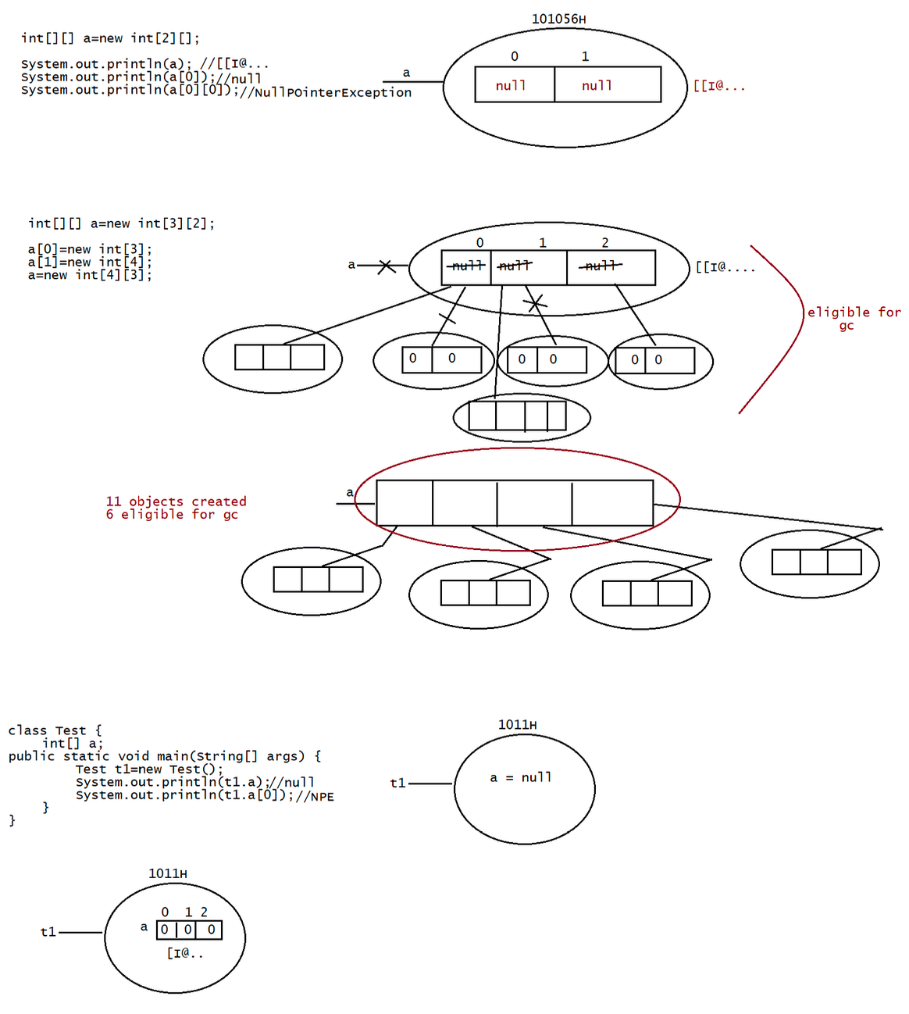
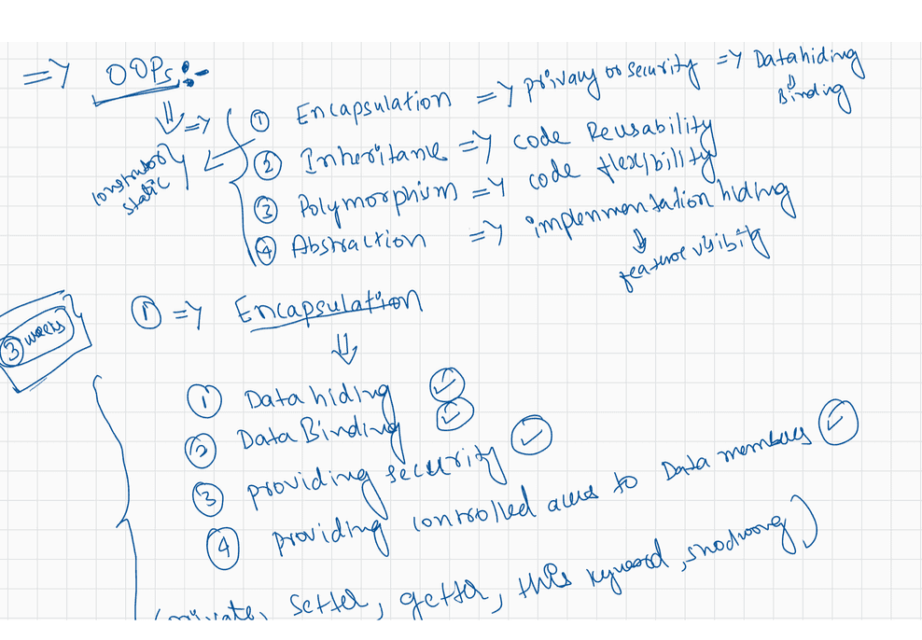

030 DOUBT
Sir, can you explain how to create multiple objects for a class, if no of Objects
is coming from console?
class Test{
;;;;
}
class Demo{
public static void main(String[] args){
Scanner scan =new Scanner(System.in);
System.out.println("Enter the no of objects to be created: ")
int number = scan.nextInt();
for(int i = 0;i<number;i++)
Test t1 = new Test();
}
}
In normal inner classes Static method is possible when i say java Outer$Inner i
getting the output how? i sented the code to you in dicord also.
Answer: higher version u can use static also.
class Outer{
class Inner{
public static void main(String[] args)
{
}
System.out.println("Inner class main method");
}
{
public static void main(String[] args)
System.out.println("Outer class main method");
}
}
javac Outer.java
java Outer
Outer class main method
java Outer$Inner
Inner class main method
Enum class also extends Object class?
Answer : yes
Q> can we call static nested class main method from outer class main method by any
ways..?
class Outer
{
static class Nested
{
public static void main(String[] args)
{
System.out.printnl("Hello");
}
}
{
public static void main(String[] args)
System.out.println("hiee");
Nested.main(new String[]{""});
}
}javac Outer.java
java Outer
sir if you recall the method local inner class, can you again discuss regarding the
type of variables we will
be able to access?
class Test
{
int i=10;
static int j=20;
public void m1()
{
int k=30;
final int m=40;
class Inner
{
public void m2()
{
LINE 1;
}
}
}
}
m1 instance -> i,j,k,m
m1 is static -> j,k,m
m2 is static -> CE
import java.util.*;
class TestGenerics1{
public static void main(String args[]){
ArrayList name=new ArrayList();
name.add("ASD");
name.add("A");
name.add("FG");
name.add(new Integer(12));
name.add(new Float(12.5));
System.out.println(name.get(0));
System.out.println(name.get(1));
System.out.println(name.get(2));
System.out.println(name.get(3));
System.out.println(name.get(4));
}
sir in last class you told that an abstract class can have inner class, but how can
we access
inner class because it cannot be access without creating an object of outer class.
//public,default,strcitfp,final,abstract
abstract class Outer{
class Inner
{
}
}
//give the implementation for all the abstract methods and then we need to access.what's mostly used abstract class or interface ?? I've watched recorded videos
multiple times but still getting silly doubts about abstraction vs interface
Answer:
interface
|
|
|
abstract class
|
|
|
class
class Launch2 {
int age = 19;
public void display() {
int age = 18;
System.out.println(age);
class Sub {
int age = 17;
public void get() {
int age = 16;
System.out.println();
System.out.println("get method:: " + age);
System.out.println("Method local inner class:: " +
this.age);
System.out.println("Outer class:: " + Launch2.this.age);
}
}
new Sub().get();
}
public static void main(String[] args) {
new Launch2().display();
}
}
int method1(){
int a=10, b= 20;
return a+b;
}
sir where will this 30 be stored,, in heap or in stack
Answer:stack becoz it is local to method
enum ExamResult
{
PASS(1),FAIL(0),ABSENT(-1),PENDING;
int result;
ExamResult(int result)
{
System.out.println("Parameterized constructor getting called");
this.result =result;
}
ExamResult()
{
this.result = -100;
}
public int getResult(){
}
return result;
}
/*
final class ExamResult extends java.lang.Enum
{
public static final ExamResult PASS=new ExamResult(1);
public static final ExamResult FAIl=new ExamResult(0);
public static final ExamResult ABSENT=new ExamResult(-1);
public static final ExamResult PENDING=new ExamResult();
int result;
ExamResult(int result)
{
System.out.println("Parameterized constructor getting called");
this.result =result;
ExamResult()
this.result = -100;
public int getResult()
return result;
}
{
}
{
}
}
*/
class TestApp {
public static void main(String[] args) {
ExamResult[] results =ExamResult.values();
for (ExamResult result: results )
{
System.out.println(result+":::"+result.getResult());
}
}
}
Sir I have written the below logic to find duplicates in array, but if a number is
present
more than twice, the message is printed more than once, can you please let me know
the logical mistake I'm makking?
int[] a ={10,20,30,20,40};
for (int i = 0; i < len; i++) {
for (int j = i + 1; j < len; j++) {
if (a[i] == a[j])
{
count++;
}
if(count>0){
System.out.println(a[i]+" is present in the provided array time
at multiple times");
count = 0;
}
}
}
Q>int[]a = {0,2,4,1,3};
for(int i=0; i<a.length; i++){
a[i] = a[(a[i]+3)/a.length];
}
s.o.p(a[1]);//2
a[0] = 0
a[1] = 2
a[2] = 4
a[3] = 1
a[4] = 3
a[0] = a[3/5]
a[0] = a[0]
a[1] = a[5/5]
a[1] = a[1]

